User Manual Ver1.0

eBOX-3310
Fanless Box PC

Copyright

Copyright notice
The information in this document is subject to change without prior notice in order to improve reliability, design and function and doesn’t represent a commitment on the part of manufacturer.
In no event will the manufacturer be liable for direct, indirect, special, incidental, or consequential damage arising out of the use or inability to use the product or documentation, even if advised of possibility of such damages.
This document contains proprietary information protected by copyright. All rights are reserved. No part of this manual maybe reproduced by any mechanical, electronic, or other means in any form without prior written permission of manufacturer.

Trademarks
All registered trademarks and product names mentioned herein are used for identification purposes only and may be trademarks and/or registered trademarks of their respective owners.

AMI is a trademark of American Megatrends, Inc.
Intel &Atom are trademarks of Intel Corporation
IBM, PC/AT, PS/2&VGA are trademarks of International Business Machines Corporation
Microsoft Windows is a trademark of Microsoft Corp.
RTL is trademark of Realtek Semiconductor Co., Ltd.

Declaration of Conformity
This restriction is subject to provide protection for system operation in business environment, which will produce, use and transmit radio frequency energy. Without notice of the instructions of the correct installation and use, it may cause harmful interference to radio communication. The interference prevention cannot be guaranteed even with proper installation according to the manual. If the device gets bad affect on the signal of radio / TV. User could insure by turn device on/off.
When this device produces some harmful interference, user can use the following measure to solve interference problem:
Setting the receiving antenna’s direction or location
Increase the distance between this device and receiver.
Plug in this device’s power connector into different circuits of the power outlet with receiver
If you need technical support, please inform the dealer or experienced radio/TV technical personnel.
Warning:
If user changes the setting unauthorized or repairs the device without any approval of the relevant authority, then user’s rights of controlling this device will be canceled.

Ordering information

Type | Description
eBOX-3310-SL1503 | 6th Generation Intel® Celeron™ 3855U 1.6GHz dual-core Processors /No Memory/No Hard Disk/2*RS-232/485(Optional)/2 Gigabit Ethernet ports/4*USB2.0&3.0/DVI-D/VGA/DC12V-24V input
eBOX-3310-SL6200U | 6th Generation Intel® Core™ i5-6200U 2.8GHz dual-core Processors/No Memory/No Hard Disk/2*RS-232/485(Optional)/2 Gigabit Ethernet ports/4*USB2.0&3.0/DVI-D/VGA/DC12V-24V input
eBOX-3310-BW5500U | 5th Generation Intel® Core™ i7-5500U 3.0GHz dual-core Processors/No Memory/No Hard Disk/2*RS-232/485(Optional)/2 Gigabit Ethernet ports/4*USB2.0&3.0/DVI-D/VGA/DC12V-24V input
eBOX-3310-BW5300U | 5th Generation Intel® Core™ i5-5300U 2.9GHz dual-core Processors/No Memory/No Hard Disk/2*RS-232/485(Optional)/2 Gigabit Ethernet ports/4*USB2.0&3.0/DVI-D/VGA/DC12V-24V input

Optional Item
Power adapter | Adapter KPL-060F,with 2 Pin terminal(Taiwan Jinlian)
Power cord | Different types of power cord
Memory | Support DDR3 1600/1333/1066 MHz, 1 * SO-DIMM Slot, Up  to 16 GB Memory Size
Hard Disk | Support 2.5"，MSATA

Technical Support and Service
Please visit: en.nodka.com to get the details.
User should collect the product information following:
-Product name and serial number.
-Attached device’s description
-User’s software’s description (operational system, vision, application software and so on)
-Full description of the product’s problem
-Full details of every error information

Warning:
1. DC 12~24V power input;
2. Package: be careful, please take the device by two hands;
3. Maintenance: please clean and maintain the surface by correct ways, only can uses the certificated or dry product to clean up.

Safety introduction
1. Please read the safety operating introduction very carefully.
2. Please store this manual so that refers it again.
3. Before clean up the device by wet cloth, please confirm that power connector is out of outlet, DO NOT use any liquid or decontamination spray to clean it up!
4. There must be an easy touched power outlet.
5. Please confirm that the device is be put on a stable platform before installation, accident fall may cause damages of device.
6. Please confirm that the voltage which is come from power outlet is fit on the requirement, before you connect the device to outlet.
7. Please arrange the power cable in a hiding place and do not cover anything on the cable.
8. Please be cautious of the warnings and notices on the device.
9. If the device is not used for a long time, shut off the power to avoid the damages by transient over voltage.
10. DO NOT allow any liquid flow into the device so that cause fire or short circuit.
11. DO NOT pull the device up by yourself, please let any certificated engineer to do that for your safety.
If you meet the following situations, please repair it by professional person:
- Power cable or connector is broken;
- Liquid flow into the device.
- Device doesn’t work properly. Or you can’t make it work through the user manual.
- This device falls or any damage;
- Some obvious damage;
12. DO NOT store the device in out of the temperature range what we suggested, NOT less then -30°C or higher than 80°C, or may damage the device.

Content
CHAPTER 1 OVERVIEW
1.1 Introductions 9
1.2 Features 9
1.3 External Overview 9
1.3.1 Front panel 10
1.3.2 Rear panel 10
1.4 Internal overview 10
1.5 Specifications 11
1.6 Dimensions 12
CHAPTER 2 INSTALLATION
2.1 Unpack the flat panel PC 14
2.2 Packing list: 15
2.3 Hard drive installation by using SATA 16
2.4 com jumper settings 16
2.5 Mounting system 17
2.5.1 Wall mounting 18
2.6 Connectors 19
2.6.1 LAN connection 19
2.6.2 Serial device connection 19
2.6.3 USB connection 20
2.6.4 HDMI connector 21
2.7 Power connector 21
2.8 Connectors Definition 21
2.9 Driver installation 25
2.9.1 Chipset driver 27
2.9.2 Graphics driver 29
2.9.3 Audio driver 33
2.9.4 LAN driver 35
2.9.5 pci driver 38

CHAPTER 3 BIOS SETTING
3.1 Introduction 42
3.1.1 Starting setup 42
3.1.2 Using setup 42
3.1.3 Getting help 42
3.1.4 Unable to reboot after configuration changes 42
3.1.5 BIOS menu bar 42
3.2 Main 43
3.2.1 System Time / System Date 44
3.3 Advanced BIOS features setup 45
3.3.1 ACPI Setting 45
3.3.2 PCI Configuration Setting 46
3.3.3 CPU Configuration 47
3.3.4 SATA Configuration 51
3.3.5 USB Configuration 52
3.3.6 SUPER I/O Configuration 54
3.3.7 pc health configuration 58
3.3.8 display Configuration 59
3.3.9 Restore ac power loss configuration 62
3.4 Chipset Settings / North Bridge 64
3.5 Chipset settings / south bridge 65
3.5.1 Audio Configuration 66
3.5.2 PCI Express Configuration 67
3.5.3 BOOT Configuration 67
3.6 Exit Option 70
3.6.1 Save Changes and Exit 71
3.6.2 Discard Changes and Exit 71
3.6.3 Load Optimal Defaults 71
3.6.4 Load Fail-Safe Defaults 71
CHAPTER 4 SYSTEM MAINTENANCE
4.1 System Maintenance Introduction 73
4.2 Motherboard Replacement 73
4.3 Cover Removal 73
A.1 Safety Precautions 74
A.1.1 General Safety Precautions 75
A.1.2 Anti-static Precautions 75
A.1.3 Product Disposal 76
A.2 Maintenance and Cleaning Precautions 76
A.2.1 Maintenance and Cleaning 76
A.2.2 Cleaning Tools 77
B.1 ALC662 Digital Microphone Configuration 78
D.1 Hazardous Materials Disclosure Table for IPB Products Certified as RoHS Compliant Under 2002/95/EC without Mercury 86

Chapter 1

OVERVIEW

Introductions
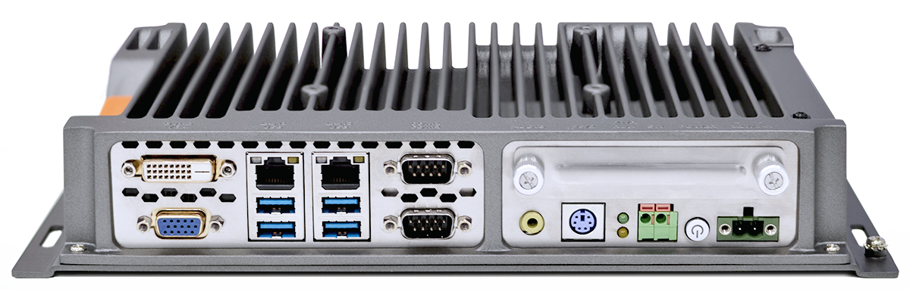
eBOX-3310 is a fanless industrial computer based on the 6th generation intel I3/I5/I7 and Celeron U processor,CPU and memory designed with modular board,All IO are based on wide temperature chip,2 intel210AT Gigabit Ethernet port,4 USB2.0/3.0 interface,VGA.DVI display interface,2 RS232/485 setup by jumper, +12~+24V DC-IN. Smart Design with external accessible HDD and CMOS battery slot, Mini-PCIe/ Easy bus expansion, for easy assembly and maintenance.

eBOX-3310 is with aluminum alloy die-casting structure,compact and rugged design,especially for more complex and harsh industrial environment. It is widely used in intelligent transportation, machine vision, industrial automation, textile machinery, railway and traffic automation.
eBOX-3310 is compatible with Windows7,WES7,Windows 10 and Linux operating system.

Features
- fully enclosed design to prevent dust intrusion.
- Fast BIOS battery and RS232/485 jumper setup for easy maintenance.
- Modular CPU board supports Intel Celeron/ Core-i3/i5/i7 CPU
- Possible to extend with Industrial Fieldbus card
- DC 12~24V, with optional power adapter.
- 2 COM supports RS232 or RS485, optional with 4* RS232/485
- Reserved connector for remote power switch

External Overview
All aluminum alloy die-casting box structure, with good shock and vibration resistance.

1.3.1 Front panel

1.3.2 Rear panel
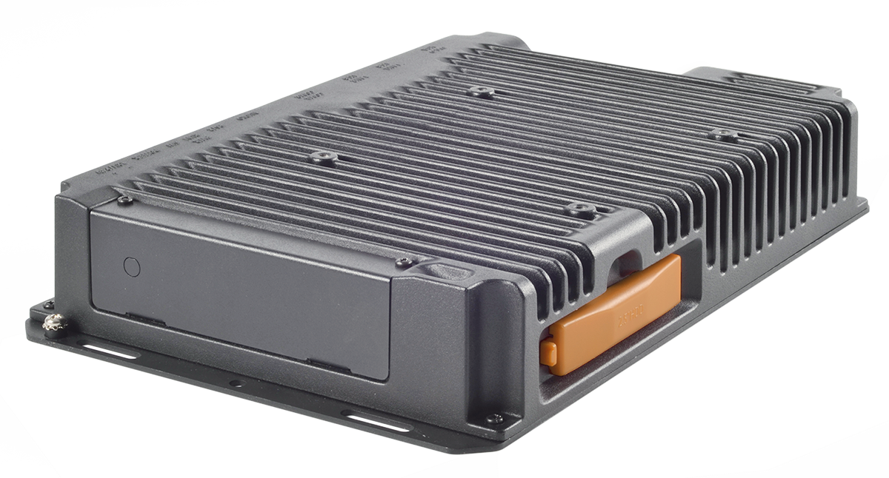

Internal overview
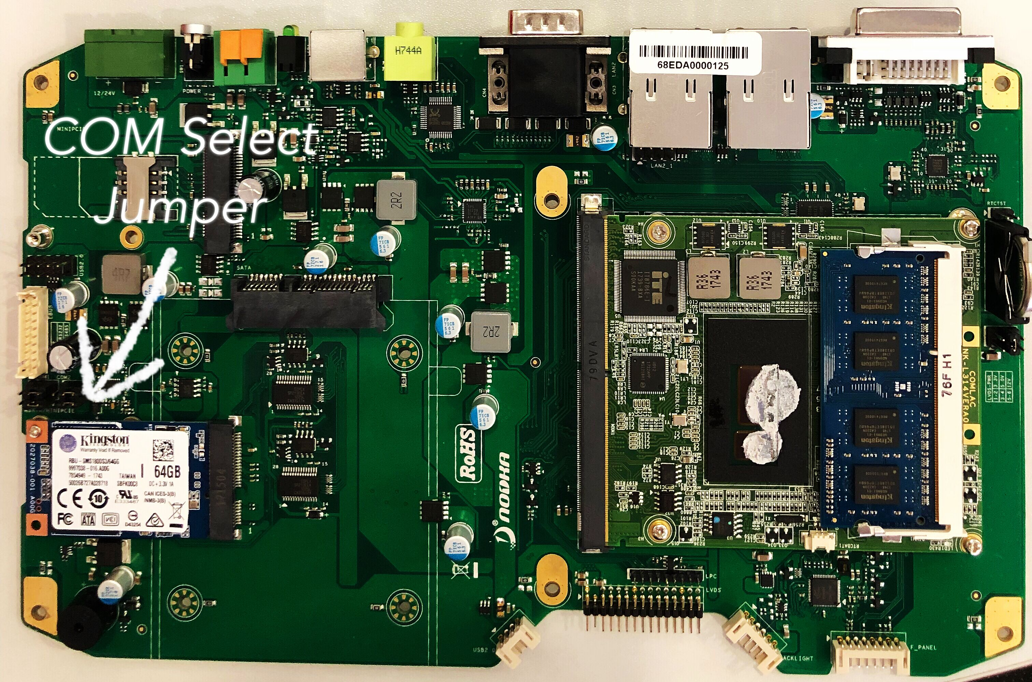

Specifications
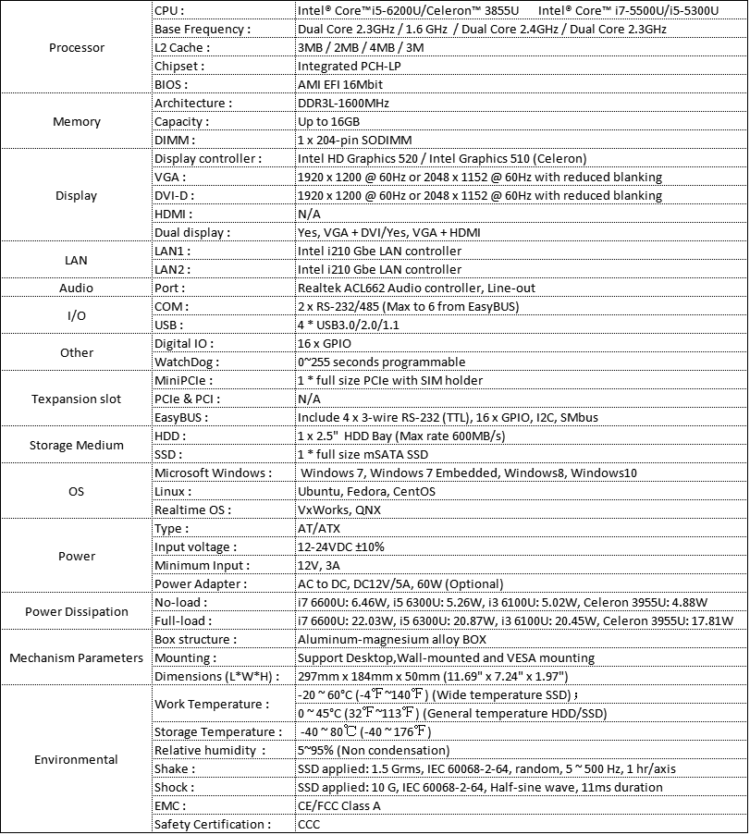

1.6 Dimensions
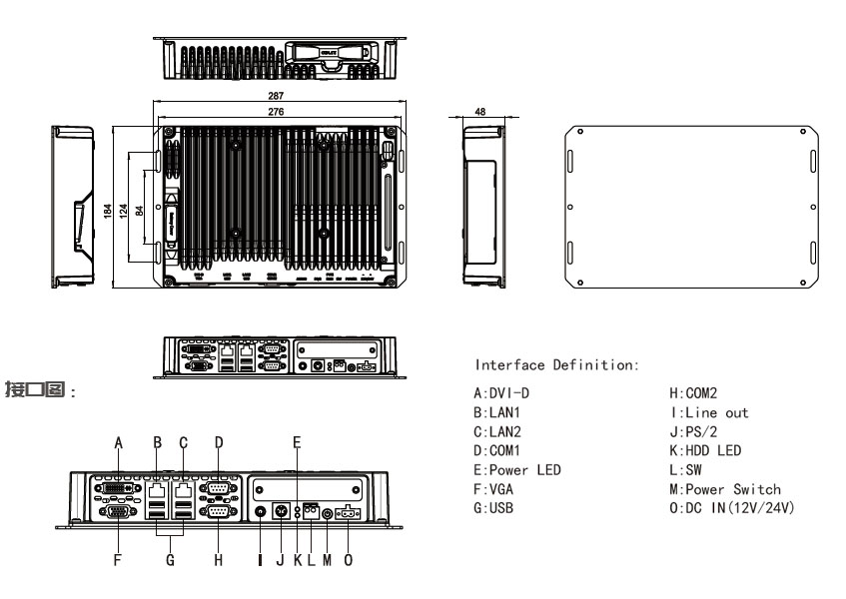

Chapter 2

INSTALLATION

Warning:
When installing the eBOX-3310, make sure to:
- Turn the power off: chance of electrocution. Turn off the monitor and unplug it from the power supply.
- Only let certified engineer change the hardware settings: Incorrect settings can cause irreparable damage to the product.
- Install the monitor with assistance: The product is very heavy and maybe damage by drops and bumps. Two or more people should install the panel PC.
- Take anti-static precautions: Electrostatic discharge can destroy electrical components and injure the user. Users must ground themselves using an anti-static wristband or similar device.

The installation steps below should be followed in order:
Step 1: Unpack the box PC;
Step 2: Check all the required parts are included;
Step 3: Install the hard drive;
Step 4: Install the compact flash card;
Step 5: Mount the box PC;
Step 6: Connect peripheral devices to the bottom panel of the box PC;
Step 7: Connect the power cable;
Step 8: Configure the system;

2.1 Unpack BOX PC
Unpack the box PC, follow the steps below:
Step 1: Carefully cut the tape stealing the outside box. Only cut deep enough to break the tape.
Step 2: Open the outside box.
Step 3: Carefully cut the tape stealing the inside box. Only cut deep enough to break the tape.
Step 4: Open the inside box.
Step 5: Lift the box pc out the box.
Step 6: Remove the peripheral box from the main box.

2.2 Packing list:
Please check out all items by following list when you open the package:
Item | Image | Quantity
eBOX-3310 |  | 1
Power cord(optional) | 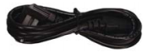 | 1
Adapter(optional) | 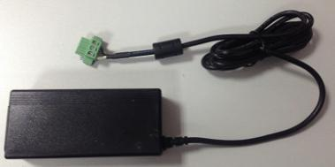 | 1
If any items are missing or damaged, contact the distributor or sales representative immediately.

2.3 Hard drive installation
Step1: Flip over this device and you can see the back of PC
Step 2: Open the orange HDD hard disk cover.
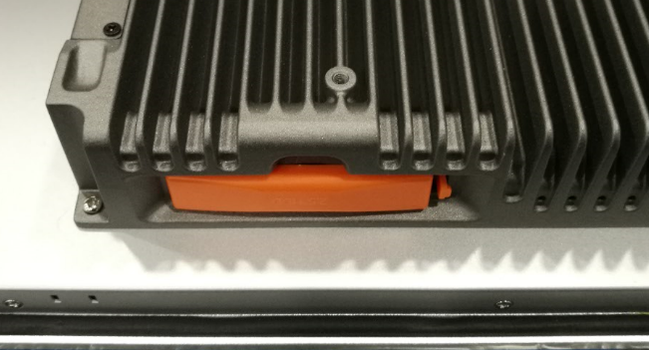
Step 3: Add rubber bracket beneath the HDD and put on the blue disk sticker to HDD.
Then inset HDD into HDD Slot ( refer to picture below)
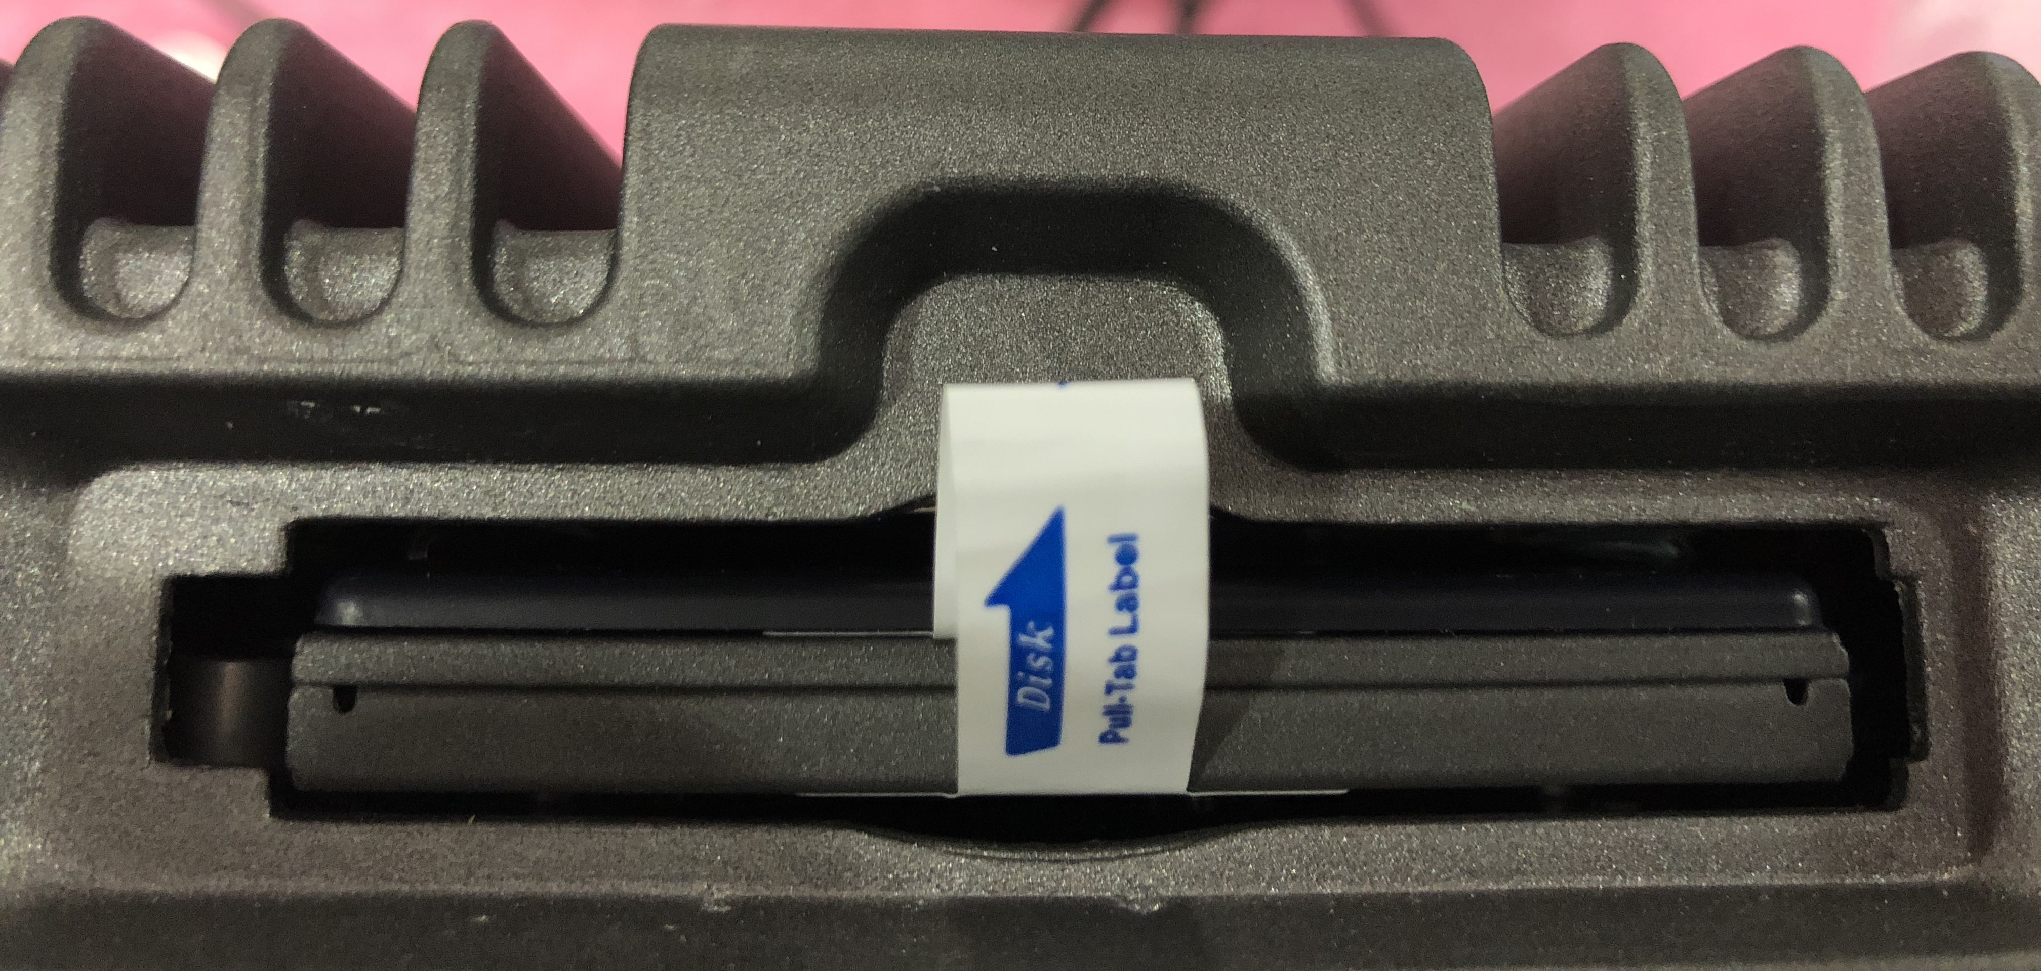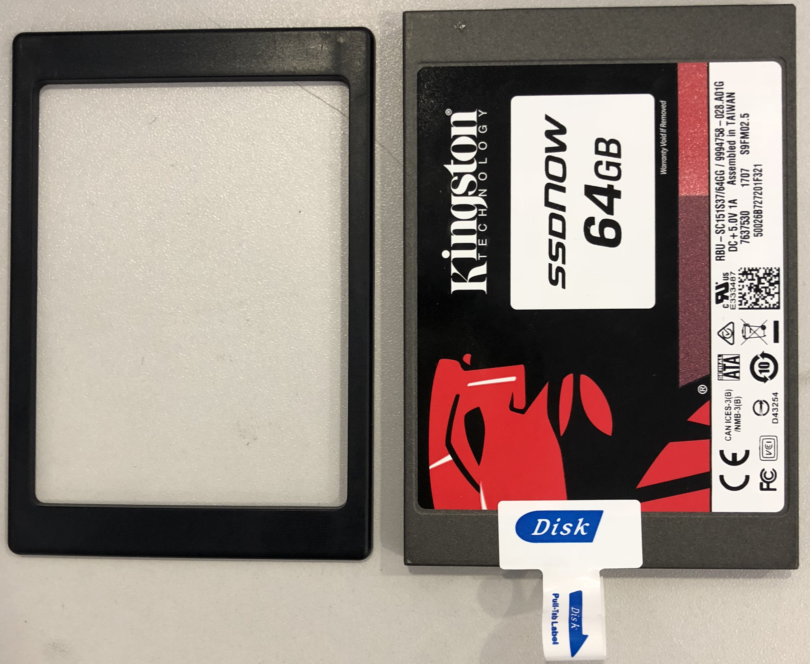

2.4 COM Jumper settings
Step1: Open the bottom cover, you can see the back of motherboard,then remove the screws on the motherboard.
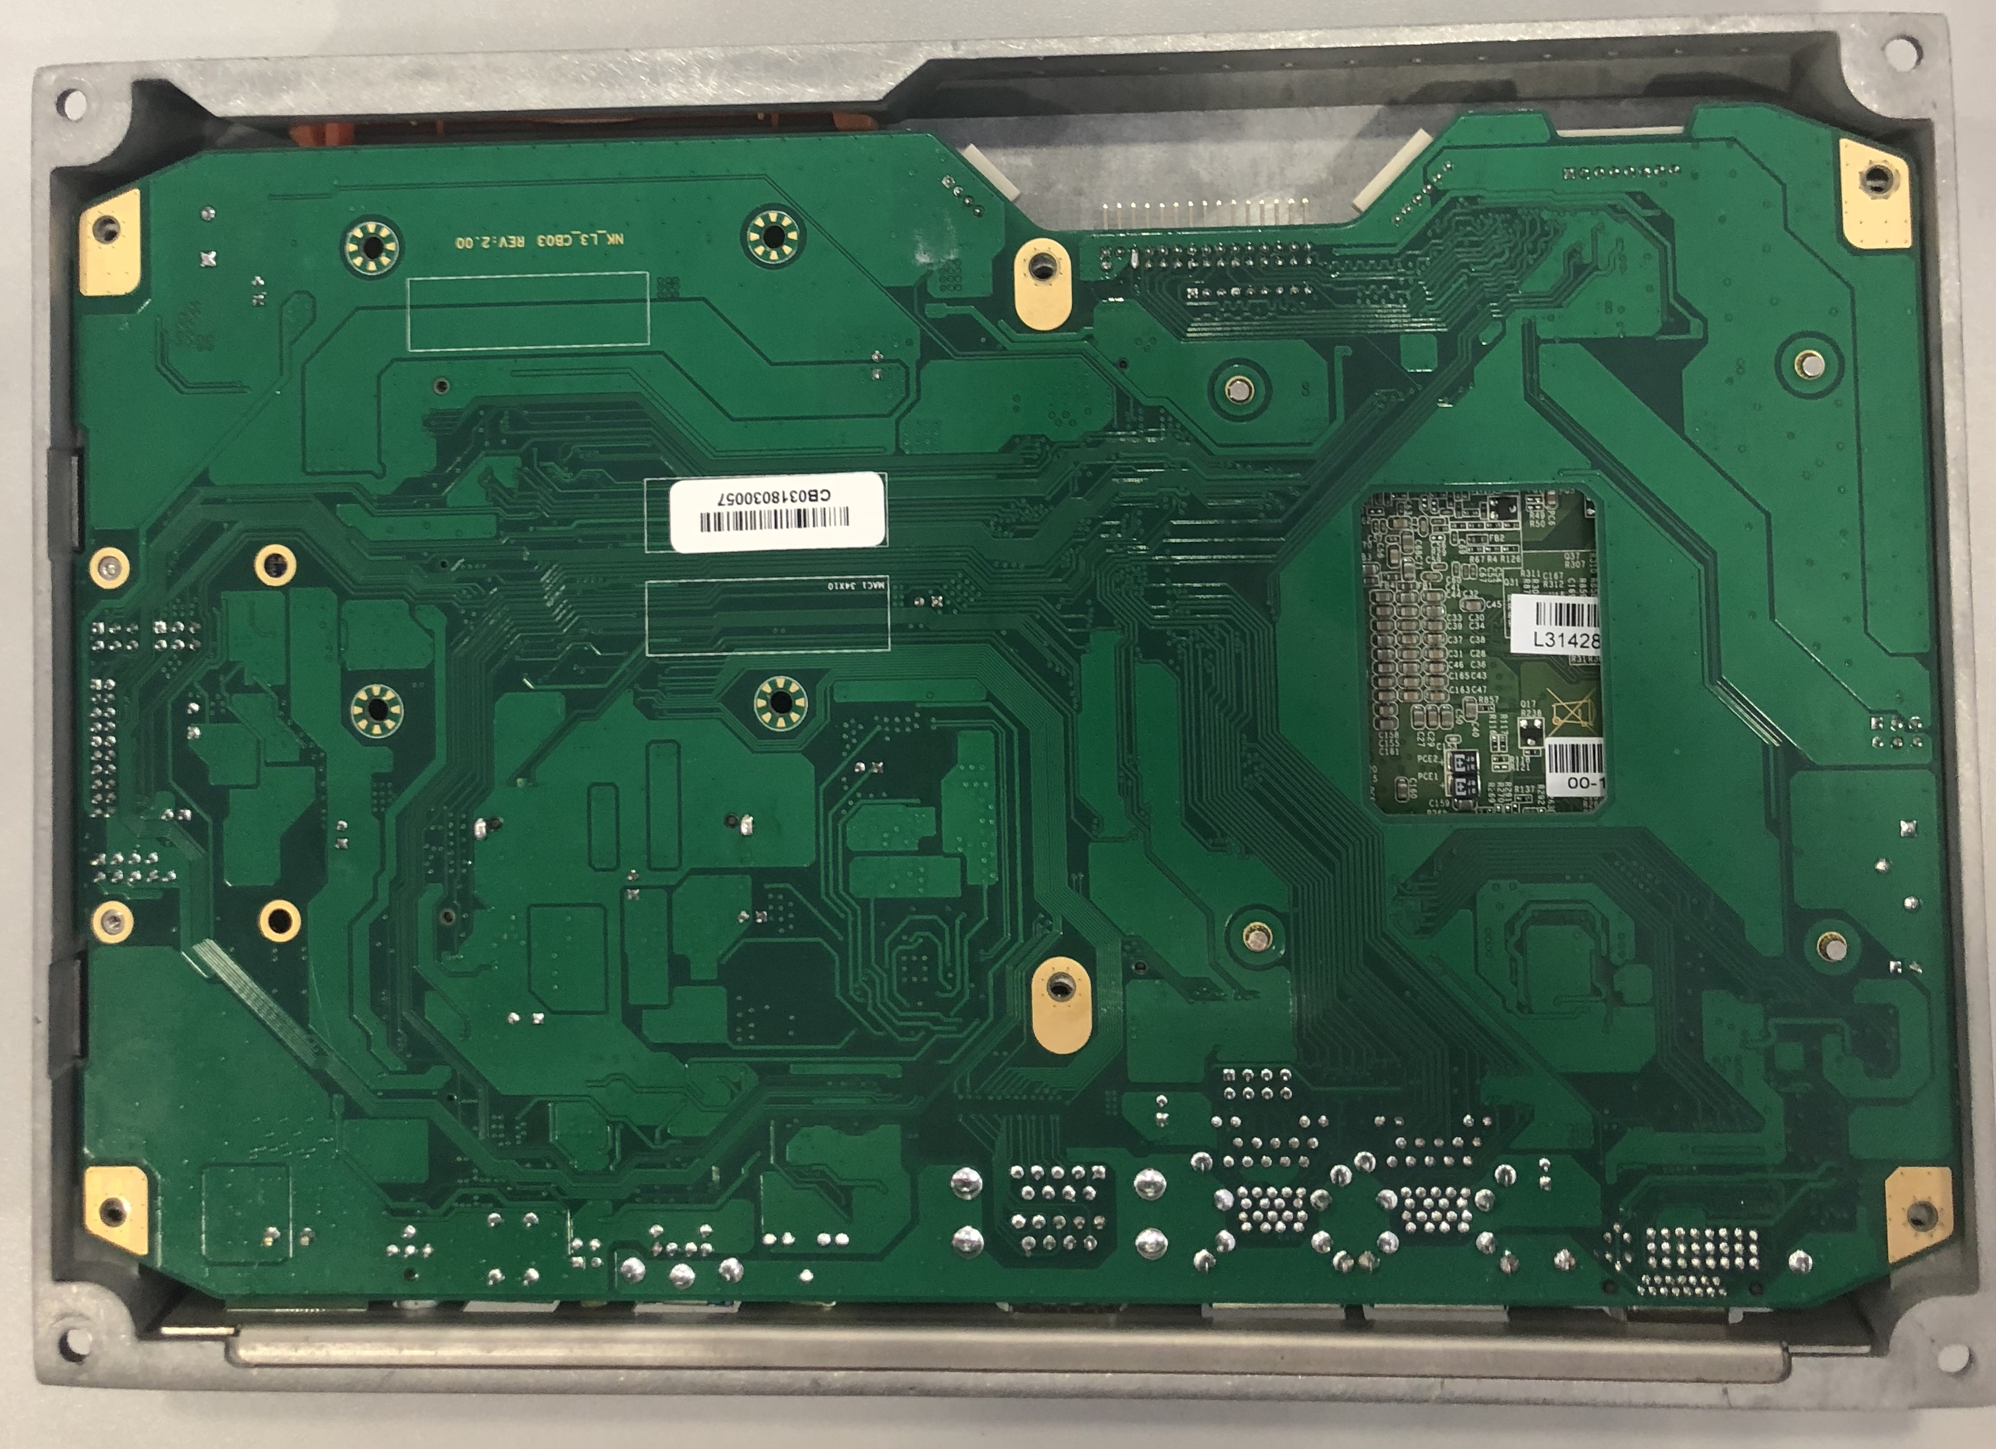

Step 2:Find the below COM jumper for setup.
Step 3: The default of Pin 1-3 and pin2-4 of COM1/COM2 are RS232,Pin 3-5 and Pin4-6 of COM1/COM2 are RS485.

2.5 Mounting system
Warning:
Dropping or bumping the eBOX PC during installation can cause serious or irreparable damage to the BOX PC
The following installation options are available:

2.5.1 Wall mounting
eBOX-3310 supports wall mounting option as picture in below:
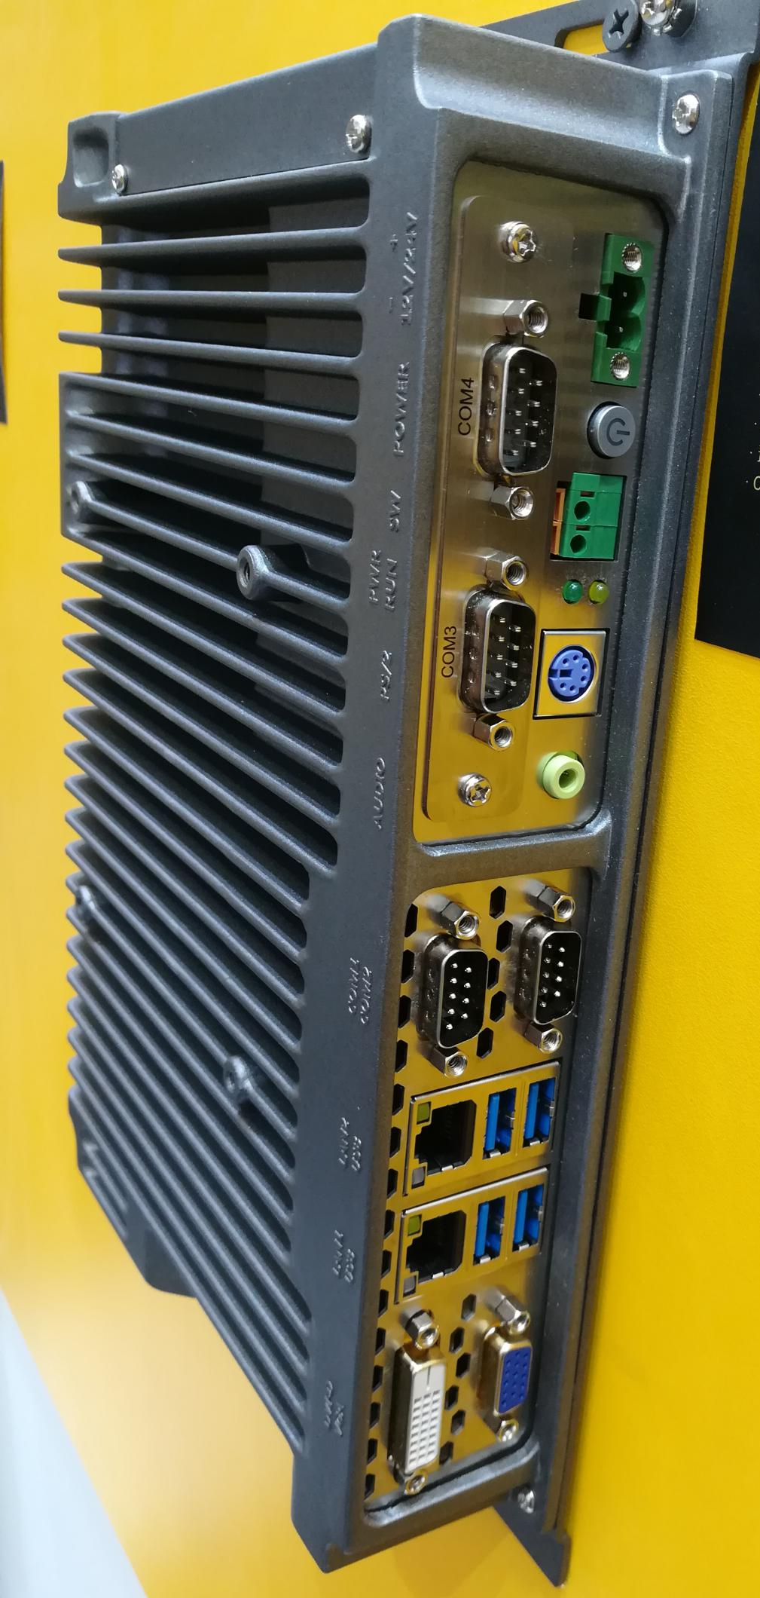

Please follow steps in below for mounting of BOX PC
Step 1: Select the location on the wall for the wall-mounting bracket.
Step 2: Carefully mark the locations of the four bracket screw holes on the wall.
Step 3: Drill four pilot holes at the marked locations on the wall, for the bracket retention screws.
Step 4: Align the wall-mounting bracket screw holes with the pilot holes.
Step 5: Secure the mounting-bracket to the wall by inserting the retention screws into the four pilot holes and tightening them

2.6 Connectors
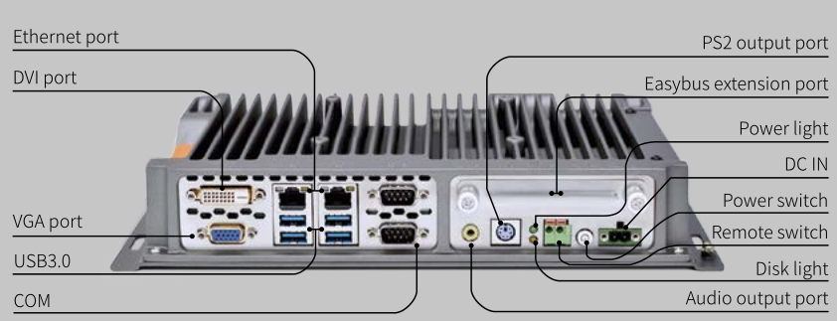

2.6.1 LAN connection
The RJ-45 connectors enable connection to an extend network. To connect a LAN cable with a RJ-45 connector, please follow the instructions below.

Step1: Locate the RJ-45 connector on the bottom panel of the eBOX-3310.
Step 2: Align the connectors. Align the RJ-45 connector on the LAN cable with one of the RJ-45 connector on the bottom panel of the eBOX-3310. Please See below Figure:
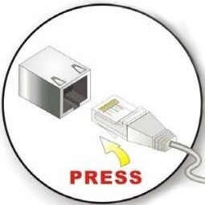

Step 3:Insert the LAN cable RJ-45 connector. Once aligned, gently insert the LAN cable RJ-45 connector into the onboard RJ-45 port.

2.6.2 Serial device connection
Step 1:Locate the DB-9 connector.
Step 2: Insert the serial connector. Insert the DB-9 connector of a serial device into the DB-9 connector on bottom panel. Please see Figure 2-14.

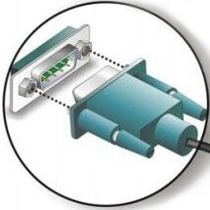

Step 3: Secure the connector. Secure the serial device connector to the external interface by tightening the two retention screws on either side of the connector.

2.6.3 USB connection
To connect USB device to the eBOX-3310, please follow the instruction below:

Step 1: Located the USB connectors.
Step 2: Align the connectors. Align the USB device connector with one of the connector on the bottom panel. Please See Figure

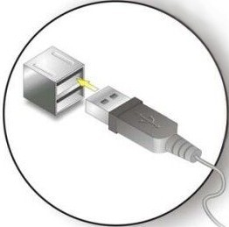

Step 3: Insert the device connector. Once aligned, gently insert the USB device connector into the onboard connector.

2.6.4 HDMI connector
Step 1: Located the HDMI connectors.
Step 2: Align the connectors. Align connector on HDMI screen cable with the connector on the external peripheral interface.
Step 3: Insert the HDMI connector. Once the connectors are properly aligned with the insert the connector from the HDMI screen into HDMI connector on the eBOX-3310, please see the figure:
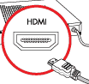
Step 4: Secure the HDMI connector. Secure the HDMI connector from the HDMI monitor to the external interface by tightening the two retention screws on either side of the connector.

2.7 Power connector
Step 1: Connect one end to the BOX PC.
Step 2: Connect the other end to the included power supply.

2.8 Connectors Definition
- COM port COM1~6 are DB9 connector and its definition is:
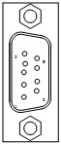 | PIN | Signal
 |  | RS-232 | RS-485
 | 1 | DCD | Data-
 | 2 | RXD | Data+
 | 3 | TXD | N/A
 | 4 | DTR | N/A
 | 5 | GND | GND
 | 6 | DSR | N/A
 | 7 | RTS | N/A
 | 8 | CTS | N/A
 | 9 | RI | N/A

The 9th pin on the DB9 defaults to R1,Though the jumper can be set to 5V or 12V. Are defined as follows:
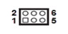 | Set up | Function
 | （1-2） | +5V
 | （3-4） | +12V
 | （5-6） | Ring（default）

- USB
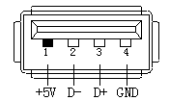
Ebox-3310 provides 2x2 standard USB interface,which can use 4 USB interfaces at the same time,The following is the definition of interface:
 | Pin | Signal
 | 1 | +5V
 | 2 | Date-
 | 3 | Date+
 | 4 | GND
- Audio（LINE_OUT）
eBOX-3310 provides a standard 3.5 headphone jack audio interface(LINE_OUT),you can use it directly

- Ethernet Interfaces (LAN1, LAN2)
We provide two 10/100/1000Mbps RJ-45 Ethernet interfaces, you can use it directly.
There are two status indicators, links status on the left side, data transmission status on the right side.
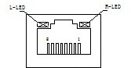 | PIN | SIGNAL | PIN | SIGNAL
 | 1 | TX0+ | 5 | TX2+
 | 2 | TX0- | 6 | TX2-
 | 3 | TX1+ | 7 | TX3+
 | 4 | TX1- | 8 | TX3-
Table: LAN connector

Network status | Left(LILED) double colors(Orange/ Green) |  | Right(ACTLED) single color(Yellow)
1000M | N/A | Constant ON | Flash | OFF
100M | Constant ON | N/A | Flash | OFF
10M | OFF | OFF | Flash | OFF
Active description | Green | Orange | Data Transferring | No Data Transferring
 | Linking indicator |  | Active status indicator
Table: Indicator of LAN connector

- PS2 Interface(PS2 Keyboard/Mouse Connector):
Slot | Pin | Definition | Pin | Definition
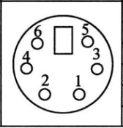 | 1 | KB_Data | 2 | MS_DATA
 | 3 | GND | 4 | +5V
 | 5 | KB_Clock | 6 | MS_Clock

- VGA Interface
Ebox-3310 provide a standard DB15 monitor interface, you can connect it directly. Here is the definition:
 | Pin | Definition | Pin | Definition
 | 1 | Red | 9 | 5V
 | 2 | Green | 10 | GND
 | 3 | Blue | 11 | GND
 | 4 | NC | 12 | DDC_Data
 | 5 | GND | 13 | HS
 | 6 | GND_R | 14 | VS
 | 7 | GND_G | 15 | DDC_Clock
 | 8 | GND_B

- DVI Interface
DVI_I connector | PIN | Function | PIN | Function
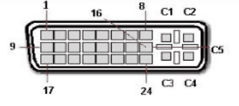 | 1 | TMDS data 2- | 13 | TMDS data 3+
 | 2 | TMDS data 2+ | 14 | +5V D-C power supply
 | 3 | TMDS data 2/4 Shield line | 15 | Landing（+5return circuit）
 | 4 | TMDS data | 16 | Hot plug detection
 | 5 | TMDS data | 17 | TMDS data 0-
 | 6 | DDC clock | 18 | TMDS data 0+
 | 7 | DDC data | 19 | TMDS data 0/5 Shield
 | 8 | Analog vertical synchronization | 20 | TMDS data 5-
 | 9 | TMDS data 1- | 21 | TMDS data 5+
 | 10 | TMDS data 1+ | 22 | TMDS Clock Shield
 | 11 | TMDS data 1/3 Shield | 23 | TMDS clock+
 | 12 | TMDS data 3- | 24 | TMDS clock-
 | C1 | Analog vertical synchronization | C4 | Analog horizontal synchronization
 | C2 | Analog Green | C5 | Analog Landing（RGB return circuit）
 | C3 | Analog Blue

- Power connector interface
eBOX-3310 offers a 2-pins power input interface:

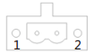 | PIN | SIGNAL
 | 1 | GND
 | 2 | 12~24V

- Switch button (PWR)
We provide a power touch switch button(PWR) to power up on front panel.

- PWR, hard drive status indicators
We provide a set of power, hard drive status indicators, you can know the procedure status by these indicators, green light constantly is for power-up. Red light flashing on hard drive indicator is shows that the hard drive is reading/writing data for now.

2.9 Driver installation
Notice:
The content of the CD may vary throughout the life cycle of the product and is subject to change without prior notice.
Visit the NODKA website download driver or contact technical support for the latest updates.
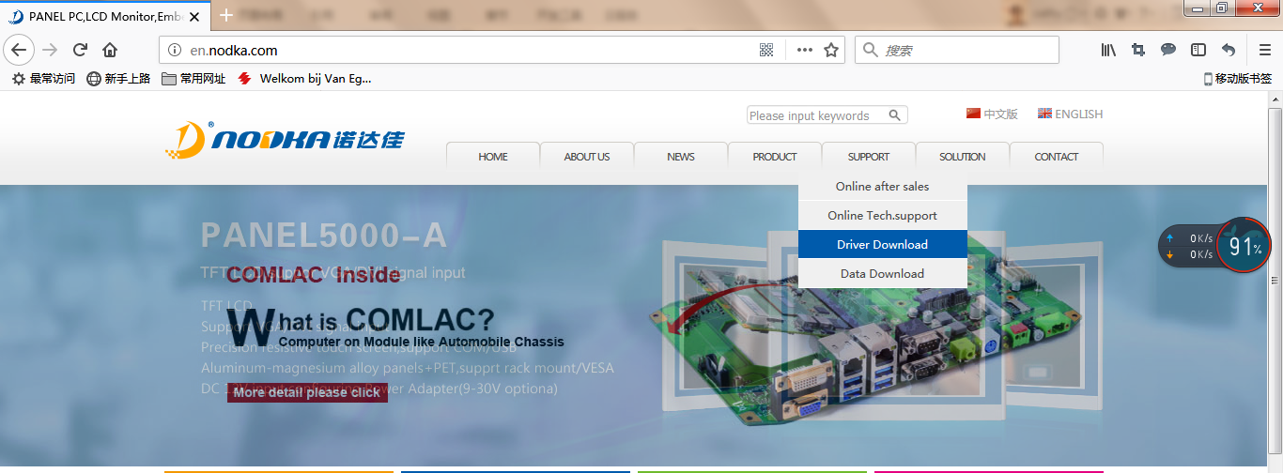
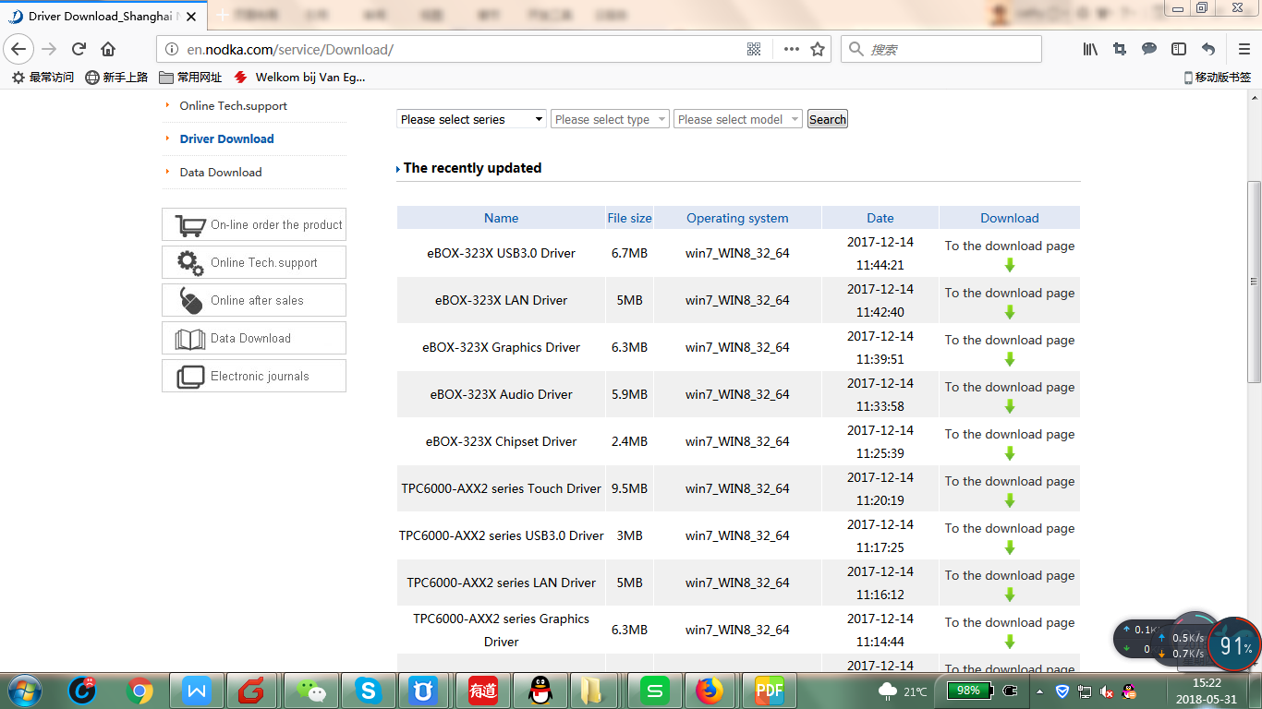
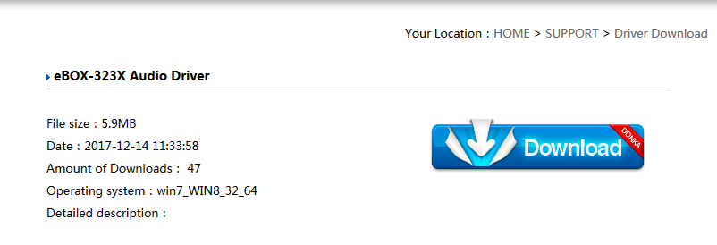
When you finish the system setup, user should setup the driver of chipset, network card, audio card, display card.
All drivers’ program will be store in an optical disc in accessory box, That will helps user to install the driver and know the functions.
Installation steps: First step is chipset’s driver (INF), then the other driver, it’s better that once you finish a installation, reboot the system, now let’s talk about method of Intel EMGD display card driver installation in Windows 10.

The following drivers can be installed on the system, each driver is in its own directory on the driver CD or the website:
- Chipset driver
- Audio
- LAN
- Graphics driver
- Intel_SIO
- TXE_3.1

2.9.1 Chipset driver
Step 1:Double-click the chipset driver,and waiting for the program to load.
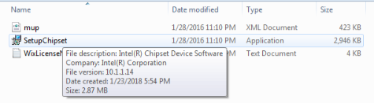
Step 2:Press<NEXT>to go to the next install page.
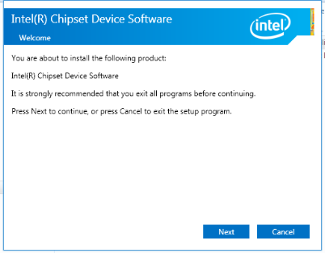
Step 3:Press<Accept>then go to the next install page:
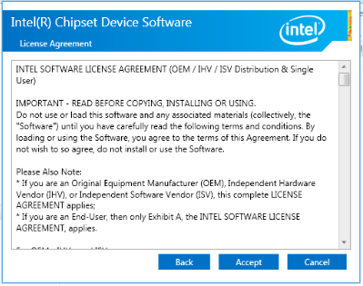
Step 4:Press<Install>go ahead 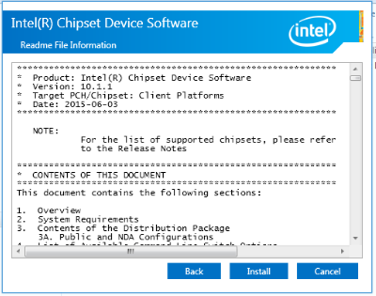
Step 5:Please wait...
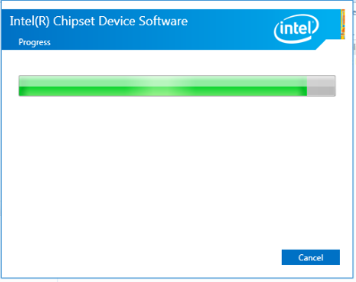

Step 6:After finish this installation, you should restart the computer immediately then you can install other device’s driver. 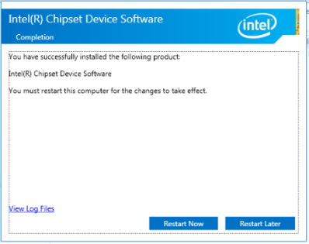

2.9.2 Graphics driver
Step 1: Double click the graphics driver program
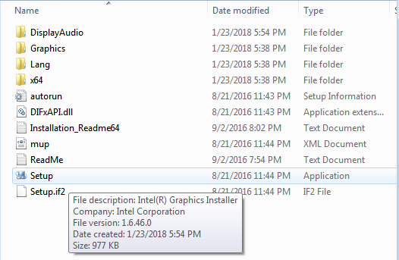

Step 2:Press<NEXT>to go to the next install page:
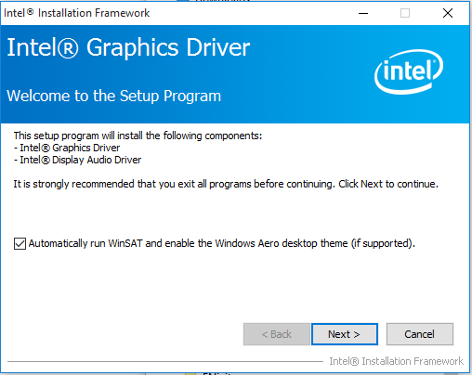

Step 3:Press<YES>to agree the license agreement then go to the next step :

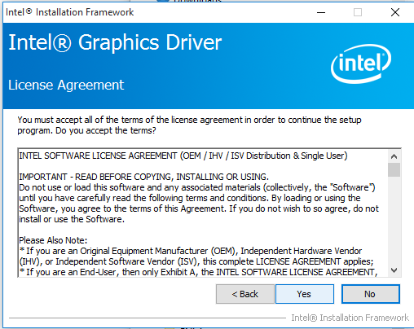
Step 4:Click <Next> to continue:
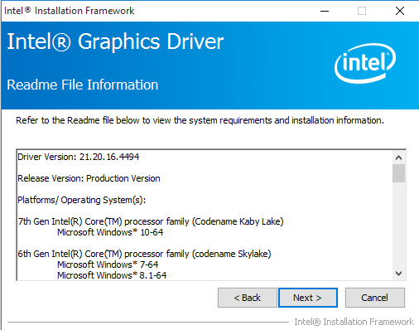

Step 5: Please wait, then press <NEXT> to go to:
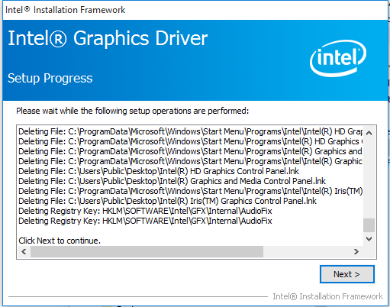
Step 6: After finish this installation, you should restart the computer immediately then you can install other device’s driver. Select the <Yes, I want to restart this computer now> and press <Finish> to reboot the computer.
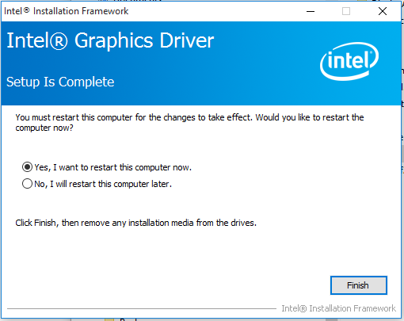

2.9.3 Audio driver
Step 1: Double click the graphics driver program
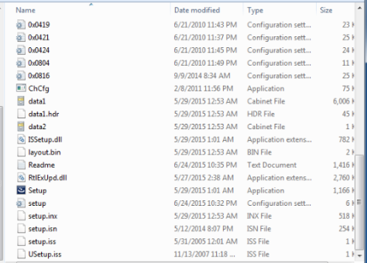
Step 2:Wait and press <NEXT>
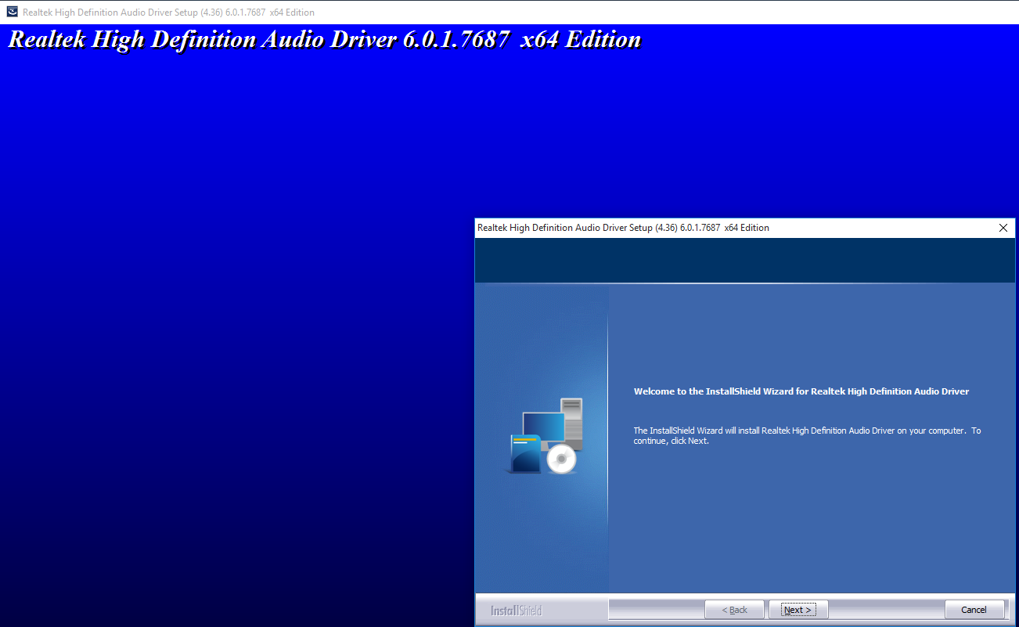

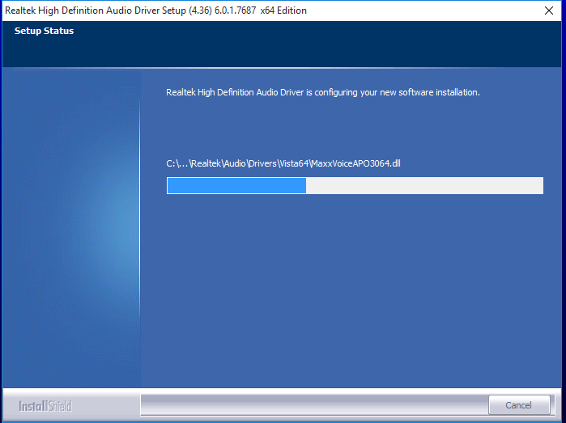

Step 3:Wait for its installation and after finish this installation, you should restart the computer immediately then you can install other device’s driver. Select the <Yes, I want to restart this computer now> and press <OK> to reboot the computer.
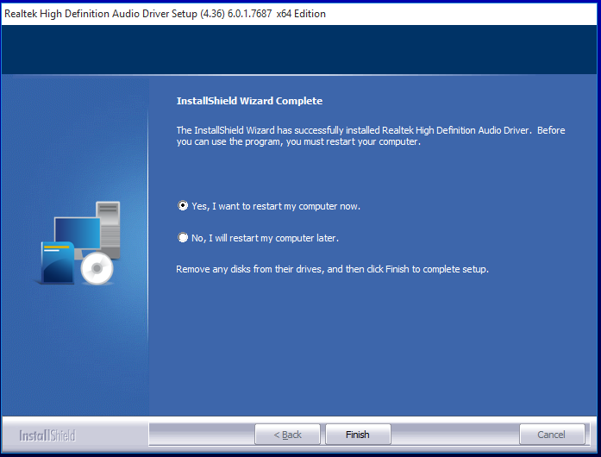

2.9.4 LAN driver
Step 1:Right-click the LAN driver and press “Run as administrator”
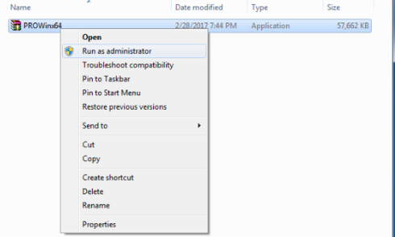
Step 2:Wait for installing driver software…
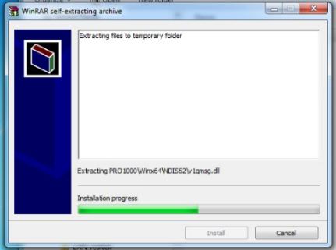
Step 3:Press<YES>to agree the license agreement then go to the next step :
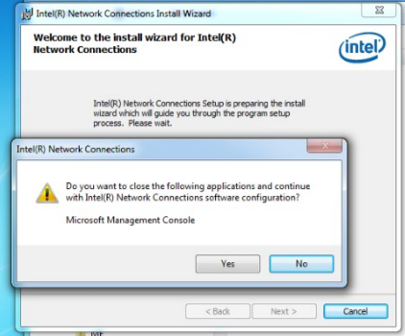
Step 4:Press <NEXT)after all options are installed in this computer
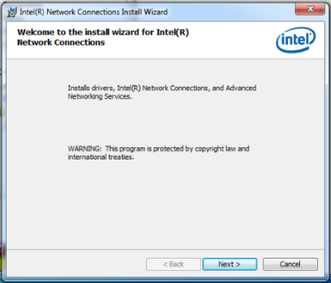
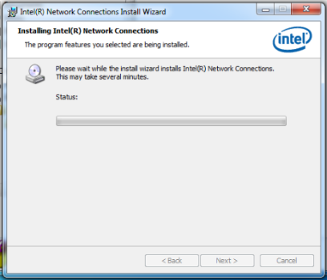

Step 5:Press <<I accept the terms in the license agreement>>,Then click<NEXT>
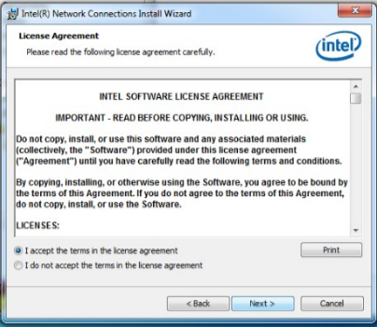

Step 6:Press <finish> to complete the installation.

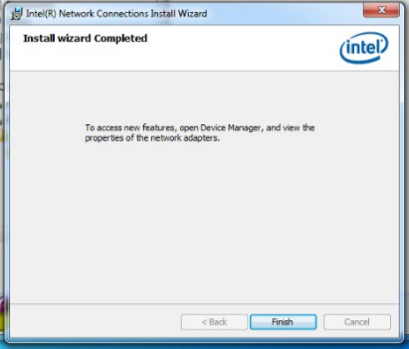
2.9.5 PCI driver
Step 1: Right-click on the desktop<Computer>-select<Computer Management>,select <Device Manager>
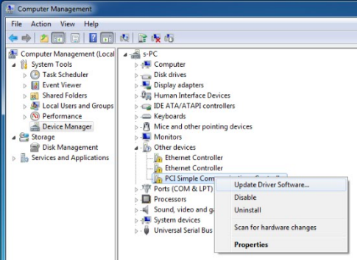
Step 2: Press<Browse my computer for driver software>:
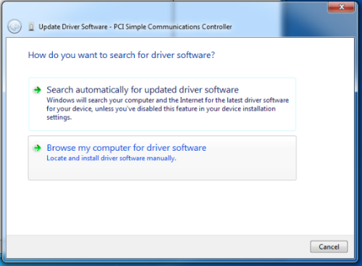
Step 2: Press <Browse> then choose driver in the <ME folder>
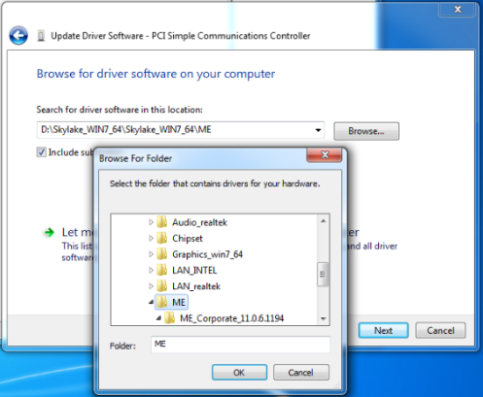
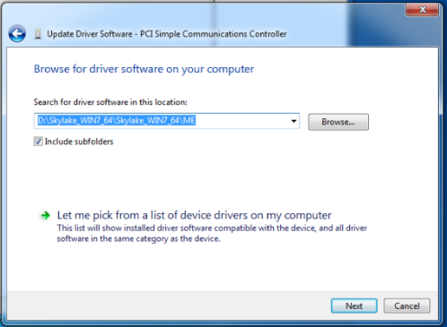
Then press <Next> to continue.
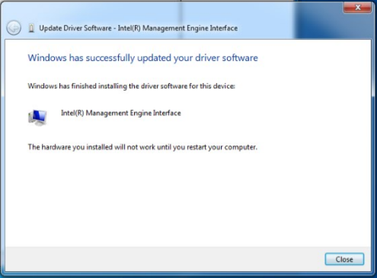

Press <Close> to finish.
Chapter 3

BIOS Setup

Introduction
The BIOS is programmed onto the BIOS chip, the BIOS setup program allows changes to certain system settings. This chapter outlines the options that can be changed.

3.1.1 Starting setup
The AMI is activated when the computer is turned on. The setup program can be activated in one of two ways:

1. Press the <DEL> key as soon as the system is turned on.
2. Press the <DEL> key when the “Press Del to enter SETUP” tips appears on the screen.

If the message disappears before the <DEL> key is pressed, restarted the computer and try again.

3.1.2 Using setup
Use the arrow keys to highlight items. Press <ENTER> to select, use the <PAGE UP> and <PAGE DOWN> keys to change entries. Press <F1> for help and press <ESC> to quit. Navigation keys are shown in.

Key | Function
Up arrow | Move to previous item
Down arrow | Move to next item
Left arrow | Move to the item on the left side
Right arrow | Move to the item on the right side
ESC | Reset
+ | Increase the numeric value or make changes
- | Decrease the numeric value make changes
F1 | General help, only for the status page setup menu and option page setup menu
F2 | Previous value
F3 | Optimized defaults
F4 | Save all the CMOS changes and reset
F12 | Print screen
Table 3-1: BIOS navigation keys

3.1.3 Getting help
When <F1> is pressed a small help window describing the appropriate keys to use and the possible selection for the highlight item appears. To exits the help Windows press <ESC> or the <F1> key again.

3.1.4 Unable to reboot after configuration changes
If the computer cannot boot after changes to the system configuration is made, CMOS defaults. Use the jumper described in Chapter 2.

3.1.5 BIOS menu bar
The menu bar on the top of the BIOS screen has the following main items:

- Main – Changes the basic system configuration.
- Advanced – Changes the advanced system settings
- PCI / PnP – Changes the advanced PCI / PnP settings
- Boot – Changes the system boot configuration.
- Security – Sets user and supervisor passwords.
- Chipset – Changes the chipset settings.
- Exit – Selects exit options and loads default settings.

The following sections completely describe the configuration options found in the menu items at the top of the BIOS screen and listed above.

Main
When you first enter the BIOS Setup Utility, you will enter the Main setup screen. You can always return to the Main setup screen by selecting the Main tab. There are two Main Setup options. They are described in this section. The Main BIOS Setup screen is shown below.

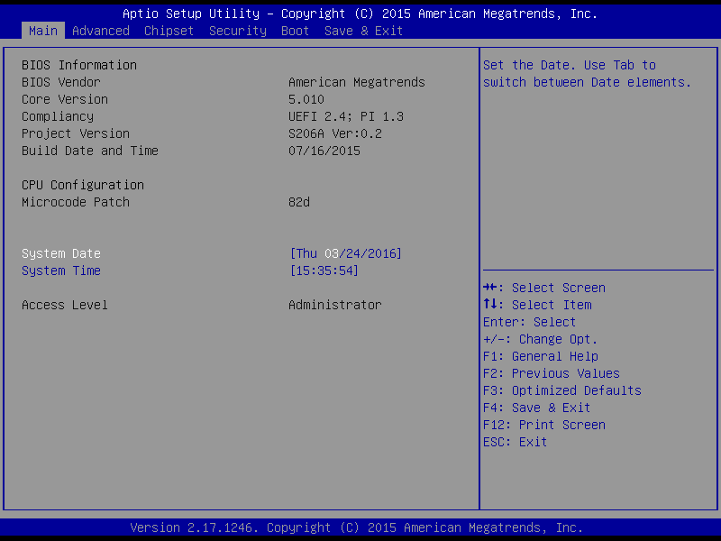

The Main BIOS setup screen has two main frames. The left frame displays all the options that can be configured. Grayed-out options cannot be configured; options in blue can. The right frame displays the key legend.
Above the key legend is an area reserved for a text message. When an option is selected in the left frame, it is highlighted in white. Often a text message will accompany it.

3.2.1 System Time / System Date
Use this option to change the system time and date. Highlight System Time or System Date using the <Arrow> keys. Enter new values through the keyboard. Press the <Tab> key or the <Arrow> keys to move between fields. The date must be entered in MM/DD/YY format. The time must be entered in HH:MM:SS format.

Advanced BIOS features setup
Select the Advanced tab from the eBOX-3310 setup screen to enter the Advanced BIOS Setup screen. You can select any of the items in the left frame of the screen, such as CPU Configuration, to go to the sub menu for that item. You can display an Advanced BIOS Setup option by highlighting it using the <Arrow> keys. All Advanced BIOS Setup options are described in this section. The Advanced BIOS Setup screens is shown below. The sub menus are described on the following pages.

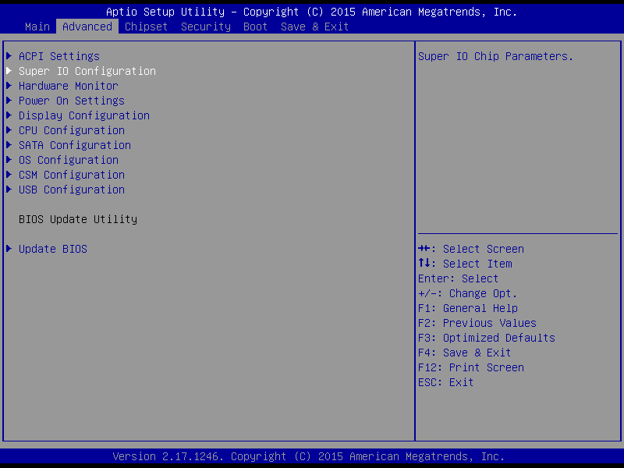

3.3.1 ACPI Setting
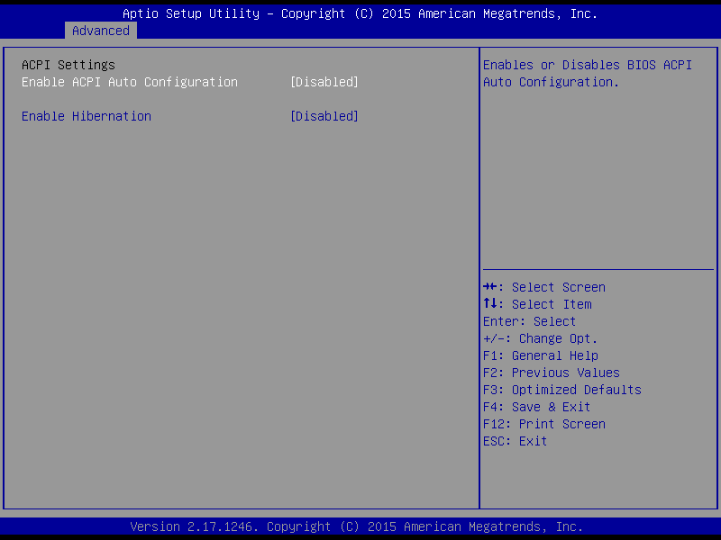

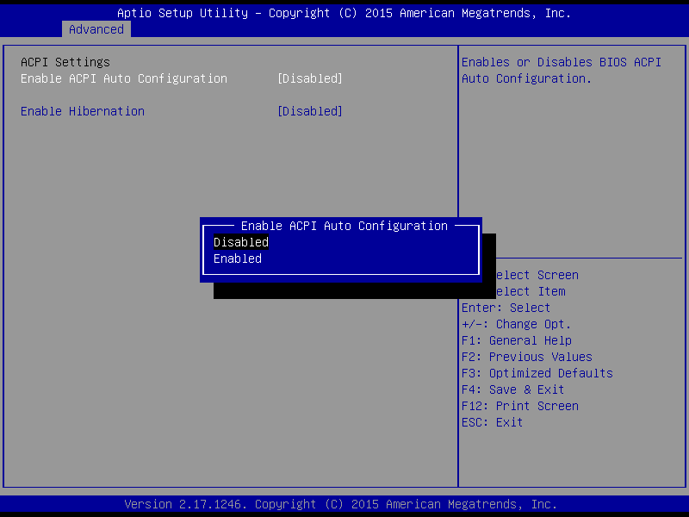

3.3.2 PCI Configuration Setting
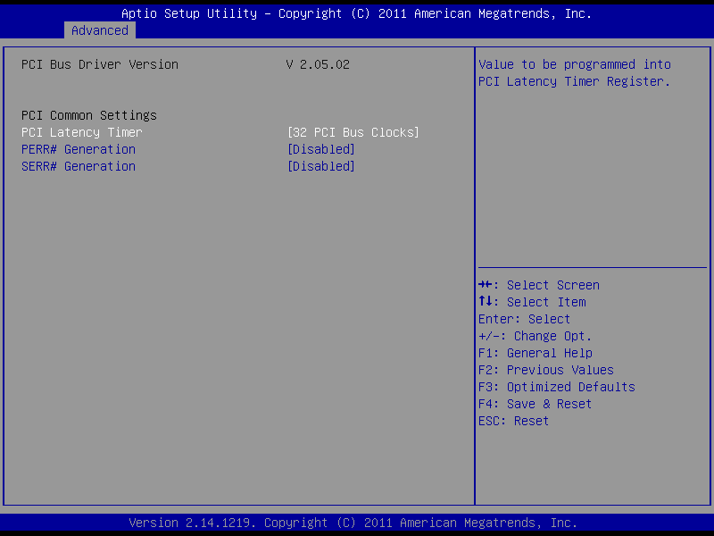
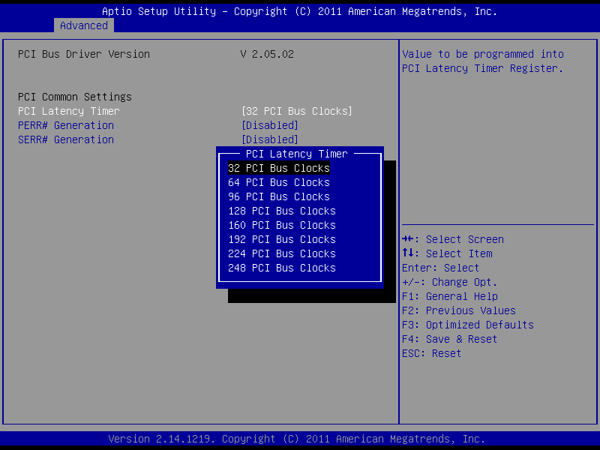

3.3.3 CPU Configuration Setting

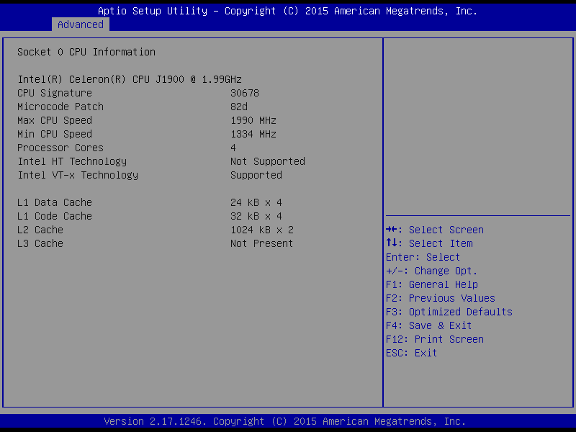
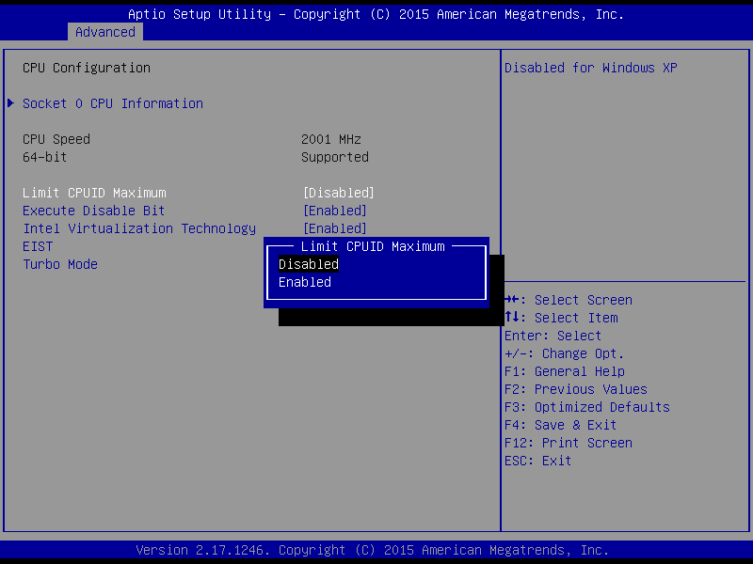

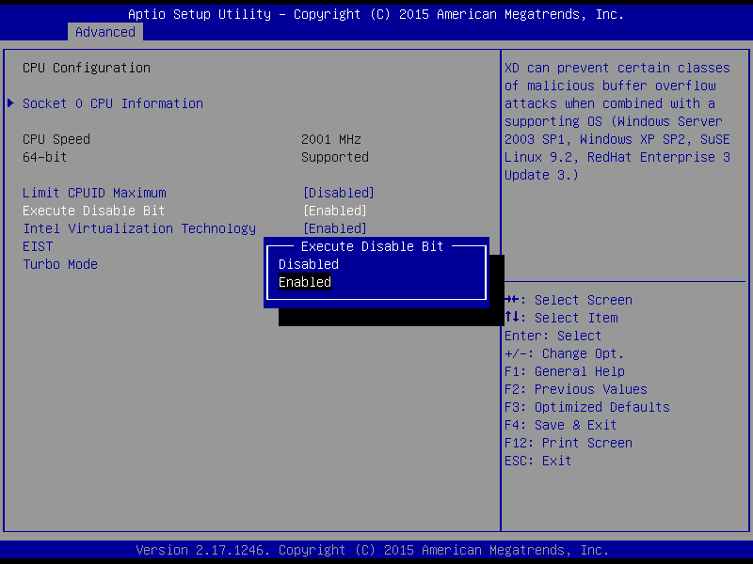
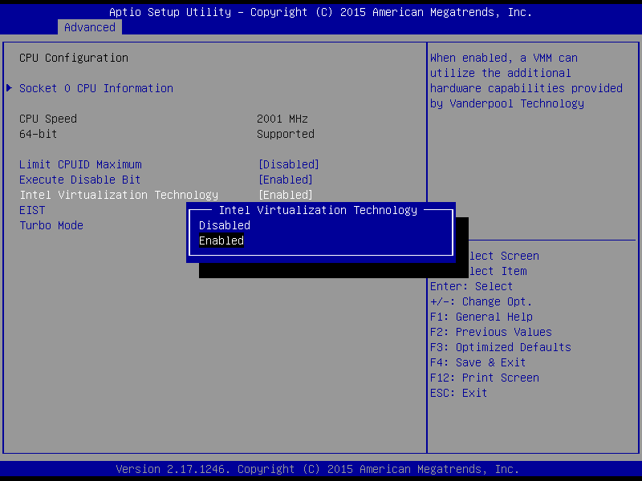

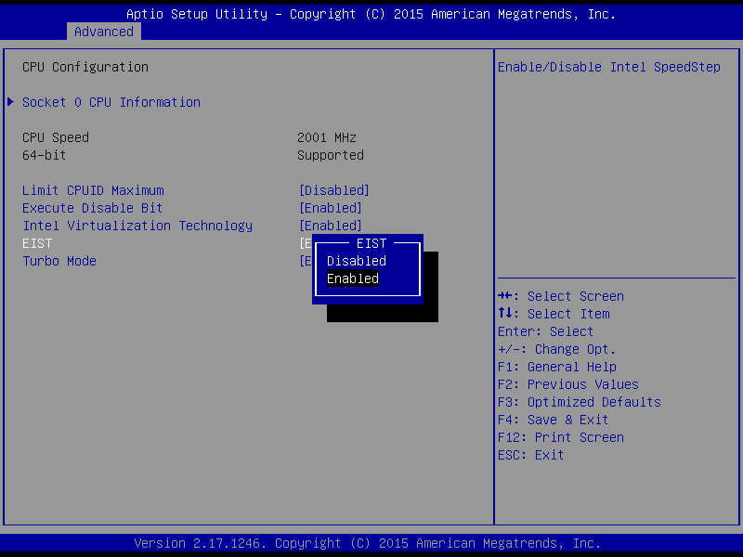

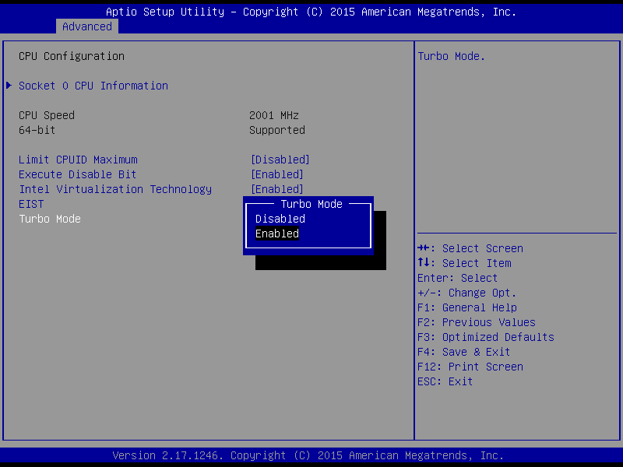

- Limit CPUID Value Limit
This item allows you to limit CPUID maximum value.
- Execute-Disable Bit Capability
This item allows you to enable or disable the No-Execution page protection technology.
- Turbo mode
This item allows you to enable or disable the turbo mode.

3.3.4 SATA Configuration
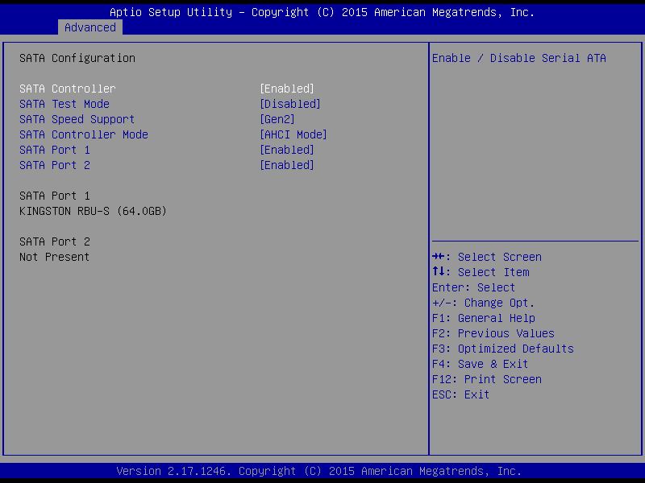

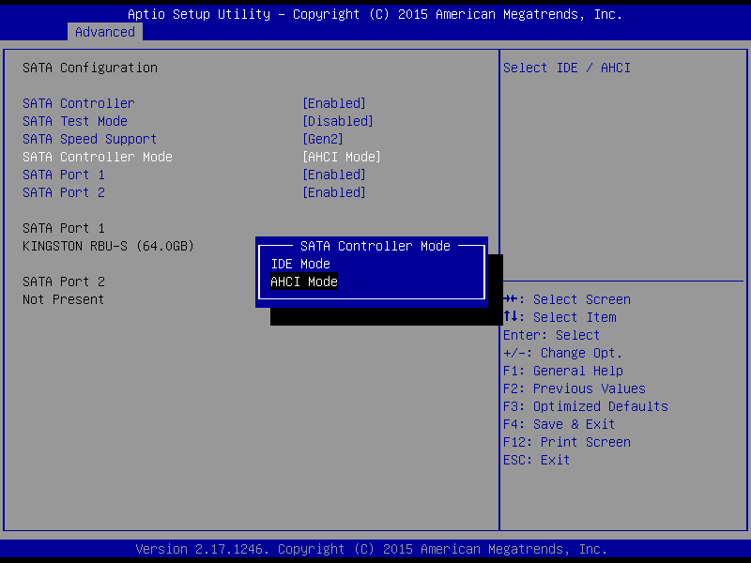
Figure 3-6 SATAconfiguration

- SATA controller mode Configuration
This item allows you to select Disabled / IDE / AHCI

3.3.5 USB Configuration

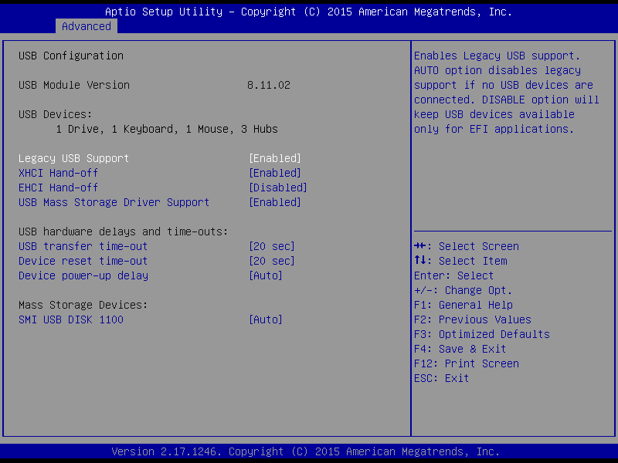

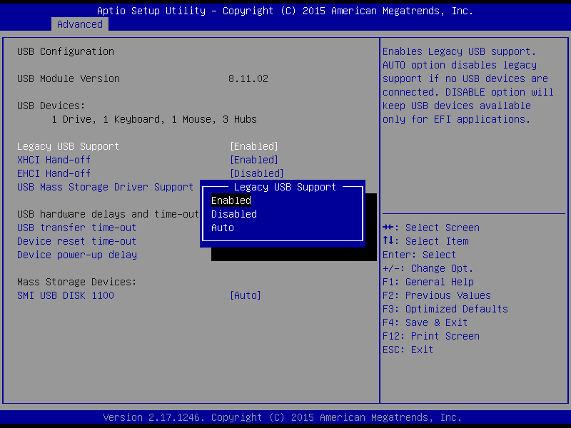

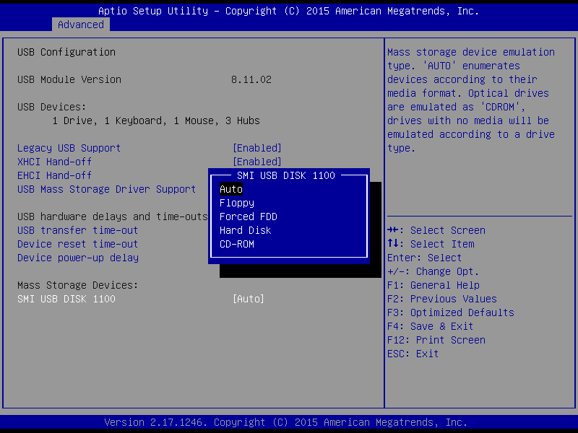

3.3.6 Super I/O Configuration

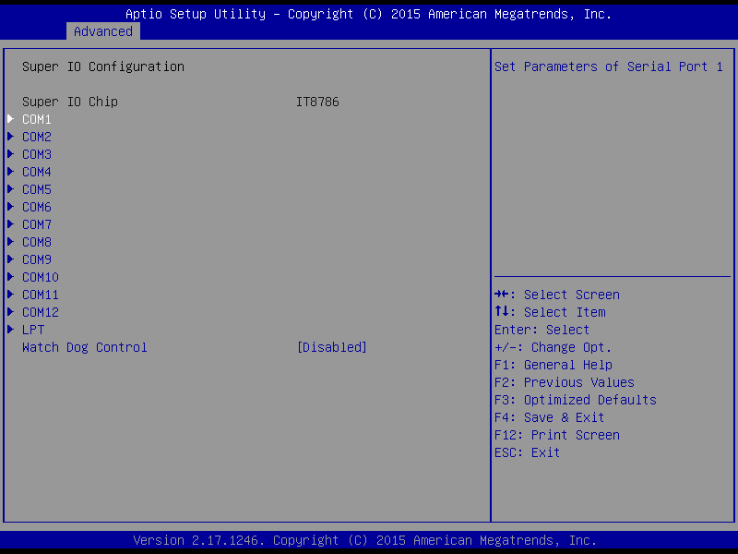

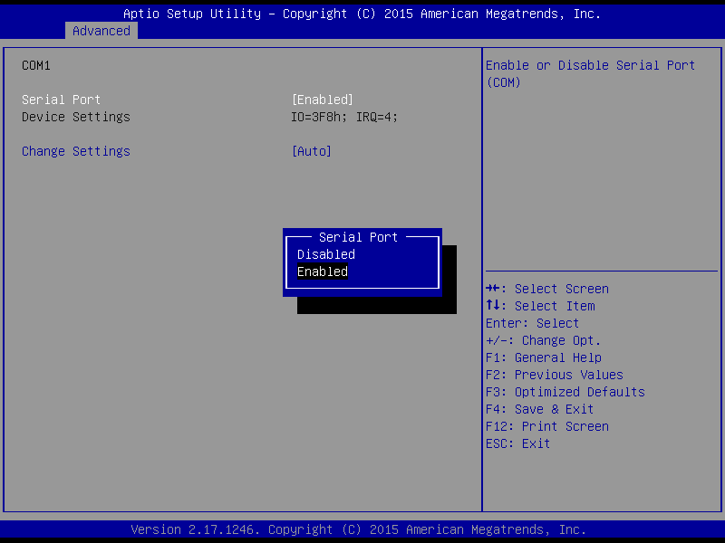
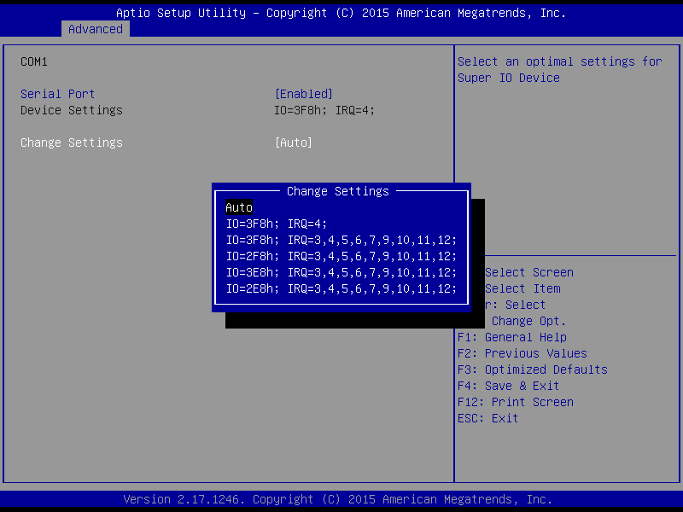

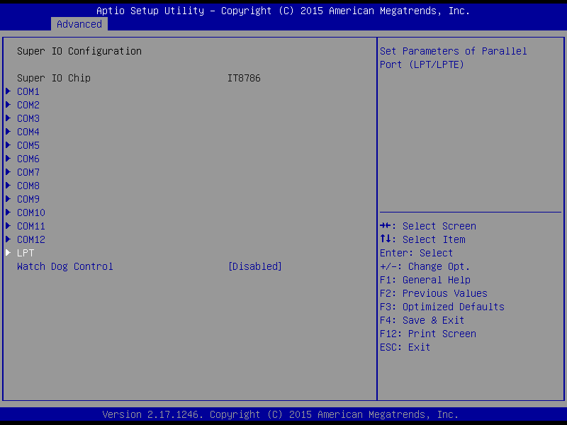
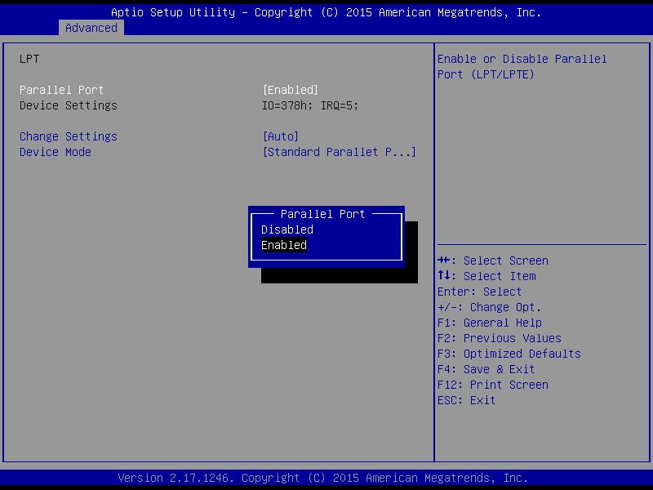
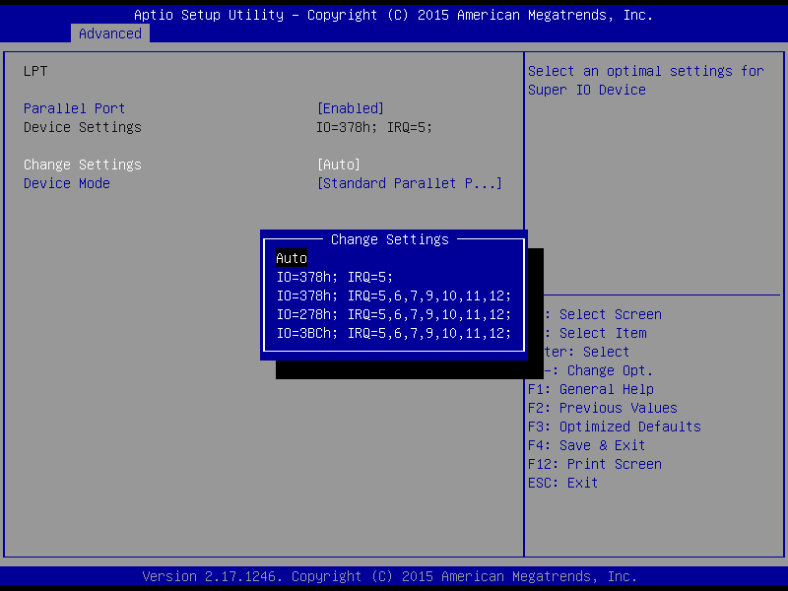
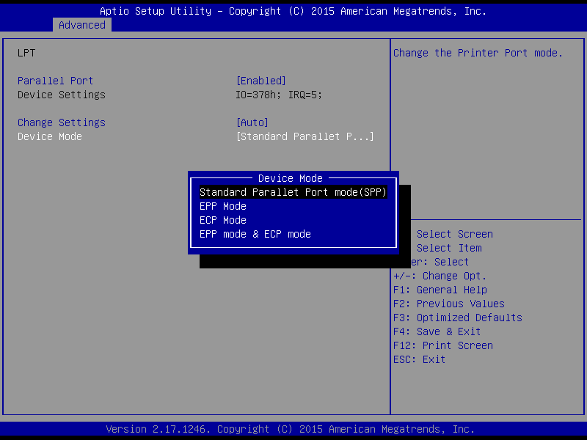

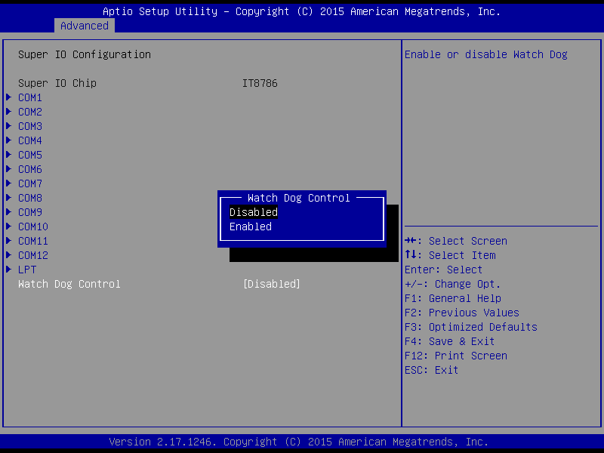

- Device settings
This item shows you the serial port1 ~ port12 of base addresses.
- Serial Port1- Port12 IRQ
This item allows you to select serial port1 ~ port12 of IRQ.
- GPIO Setting
These 6bit GPIO are extracted from SIO, but the M/B eBOX-3310 does NOT lead out this function, so this configuration is invalid.

3.3.7 PC Health Status

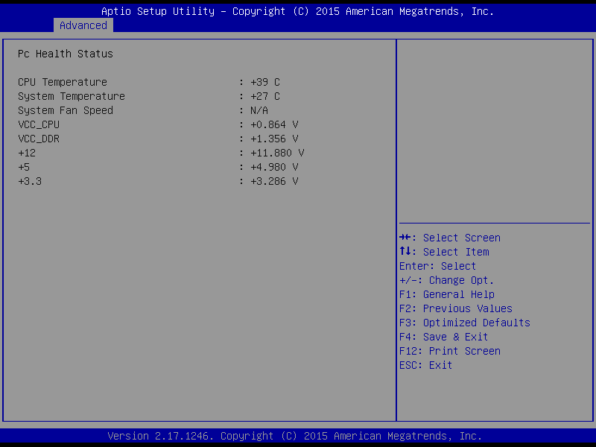

3.3.8 Display configuration

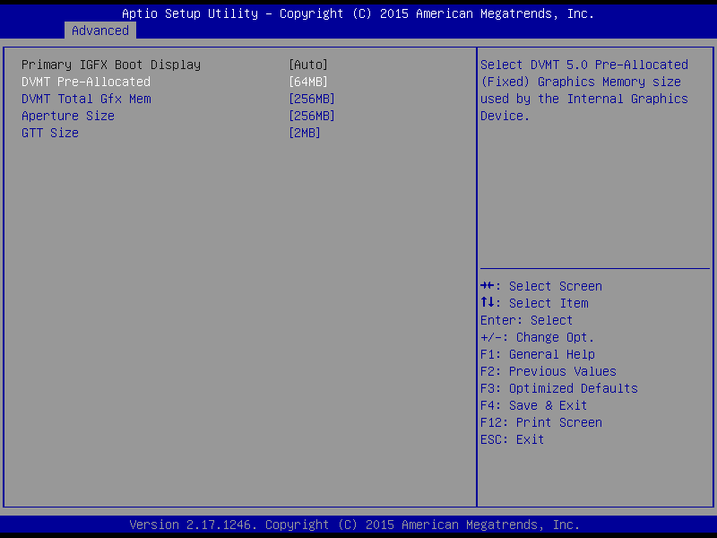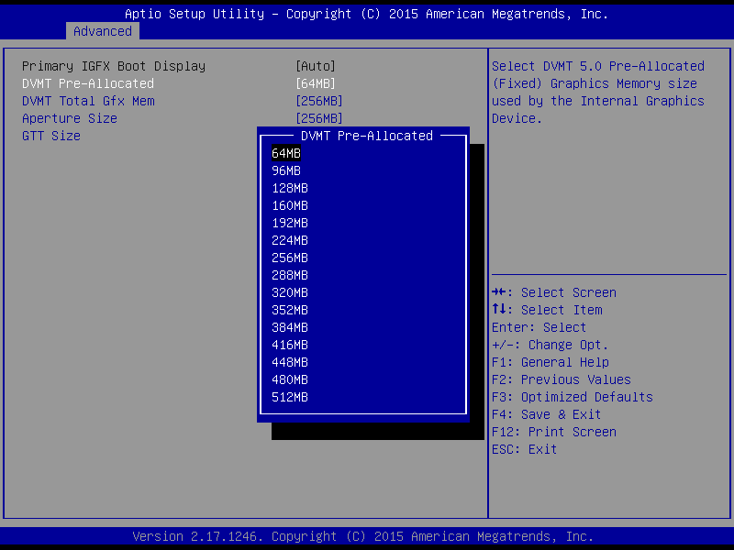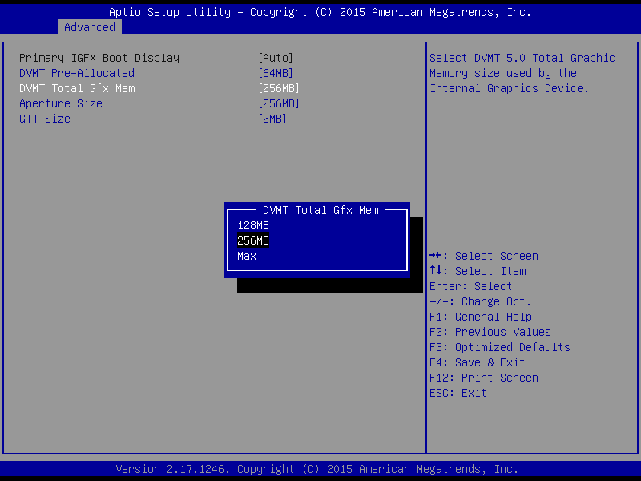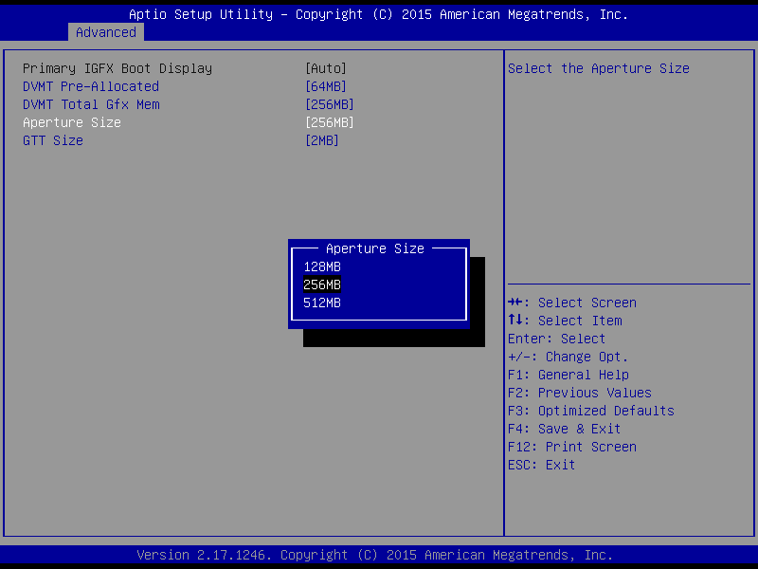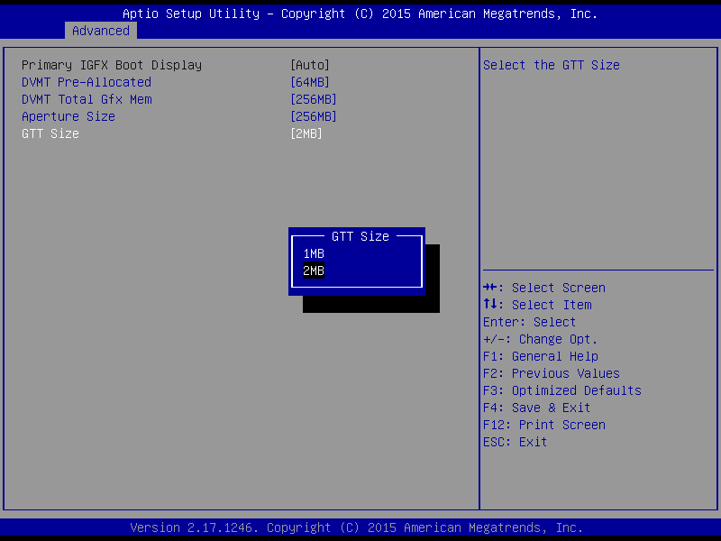
Figure 3-12DisplayConfiguration

- This selection item mainly for display application configuration.

3.3.9 Restore AC Power LOSS Configuration

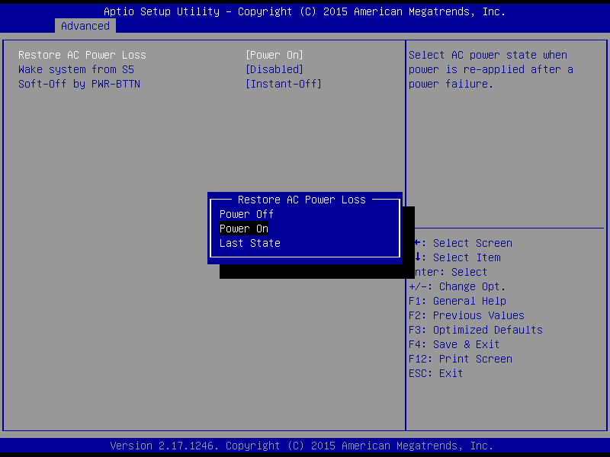
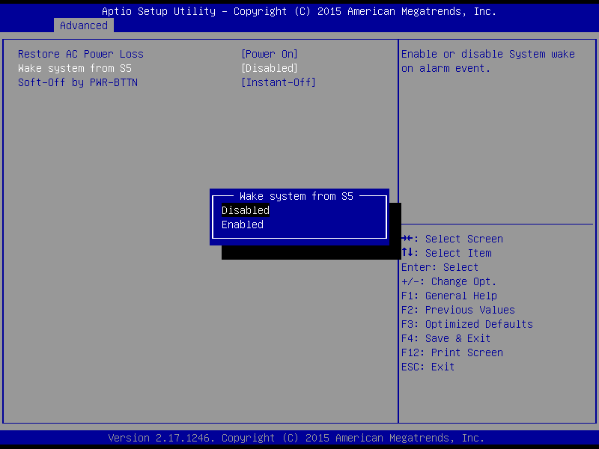

Power OFF: After accidental power-off, the device won't automatically boot-up when power-on again.
Power ON: After accidental power-off, the device will automatically boot-up when power-on again.
Last State: After accidental power-off, the device will recover to the state of the former state before power-off. i.e.: If the former state is "Power On", then the device will automatically boot-up when power-on again; if the former state is "Power off", then the
device will remain power-off when the power- on again.

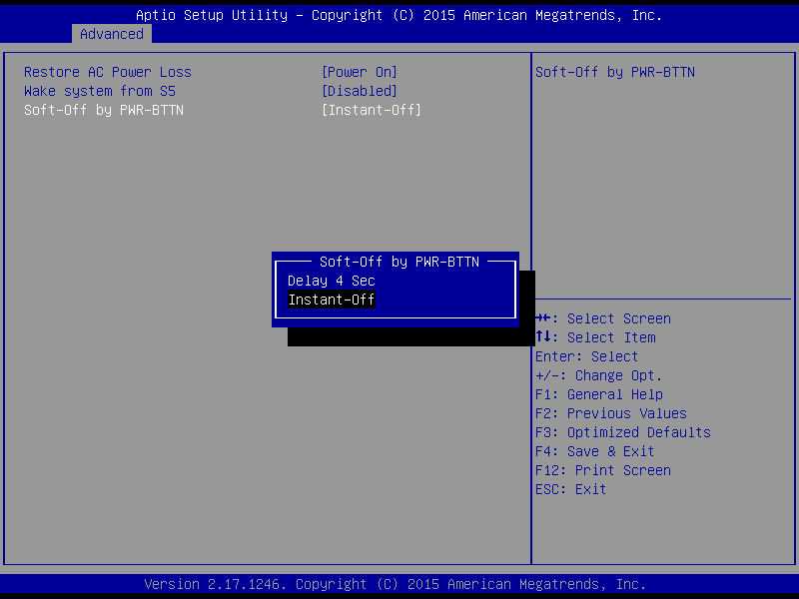

Chipset Settings/ North Bridge

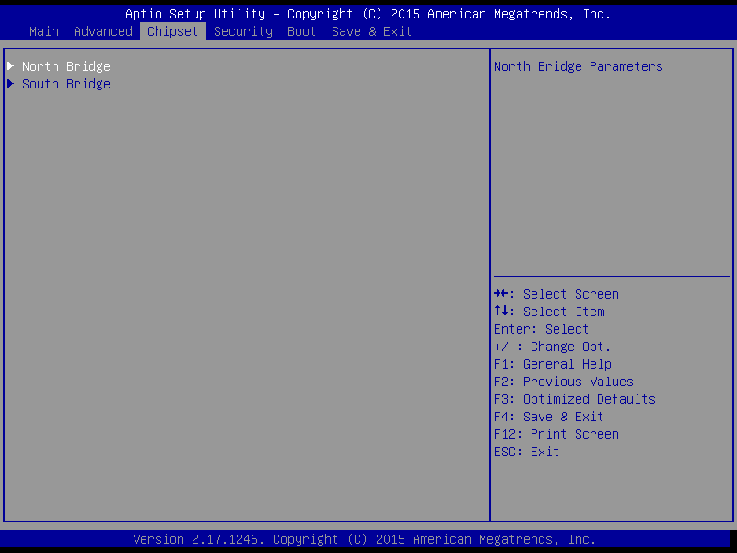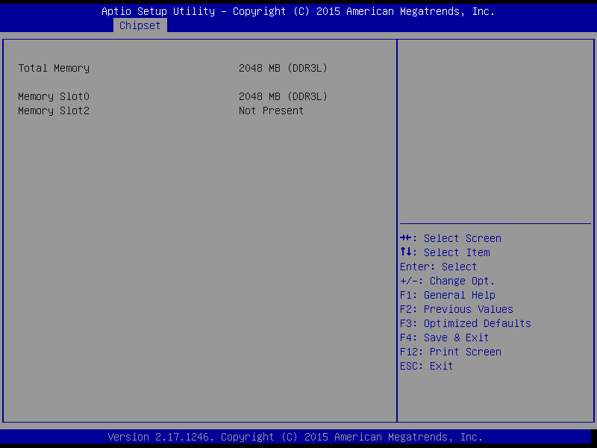

Chipset settings/ south bridge

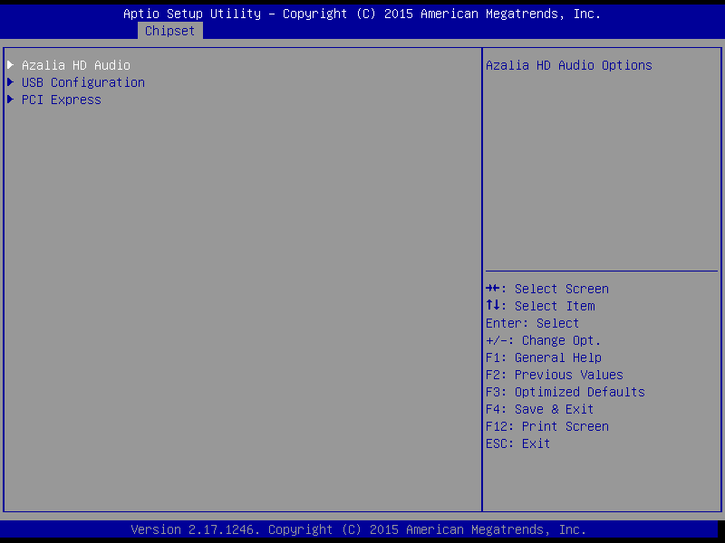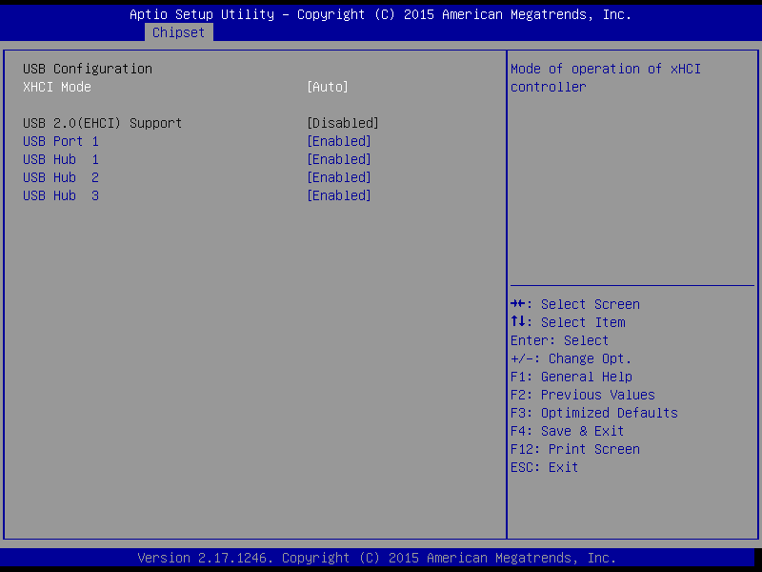

Audio Configuration
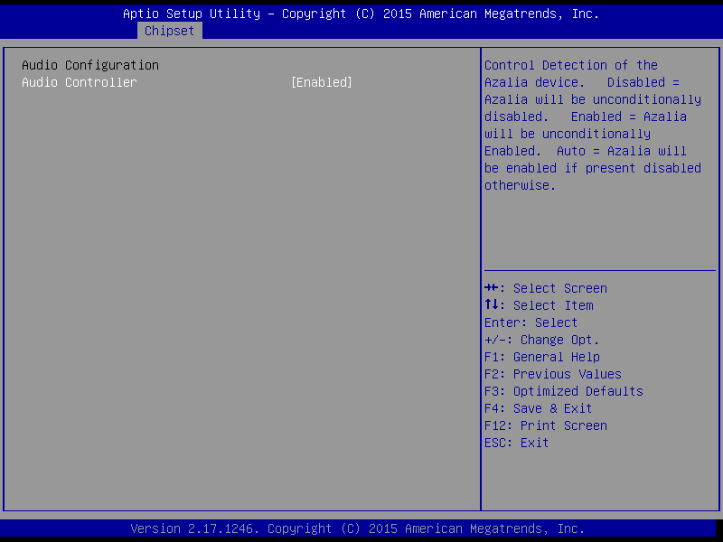
- This selection item is for Chip integrated Audio configuration.

PCI Express Configuration

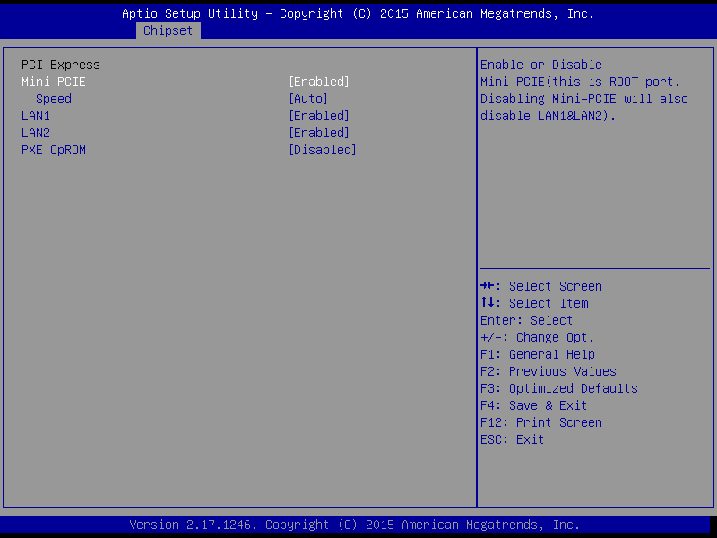

- Mini-PCIE Ports Configuration
- PCIE Port 1are allocated to onboard LAN1 and LAN2

BOOT Configuration

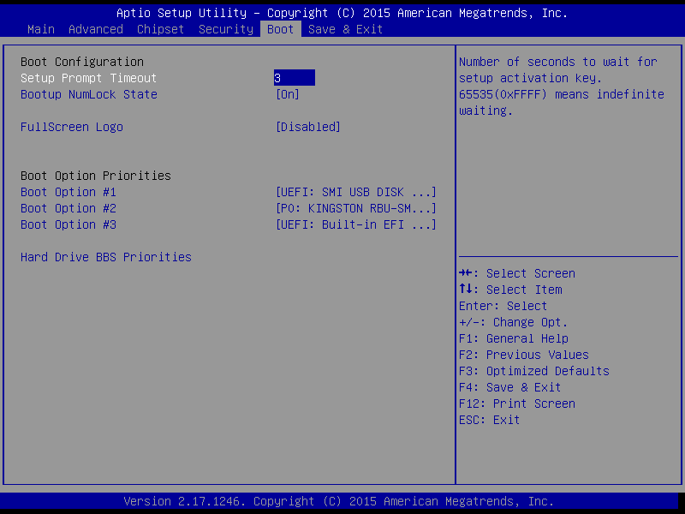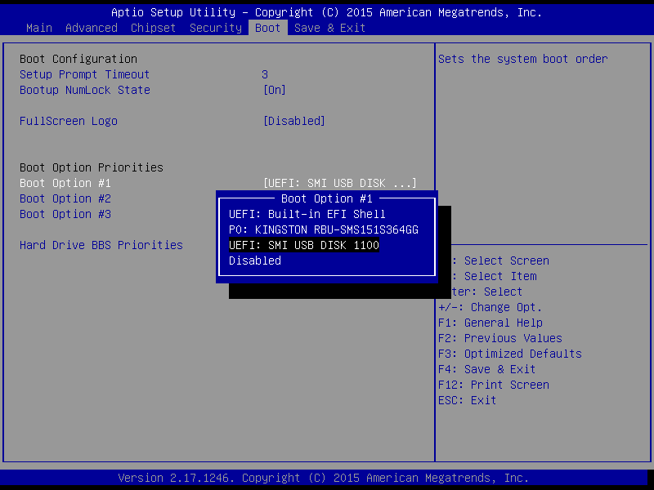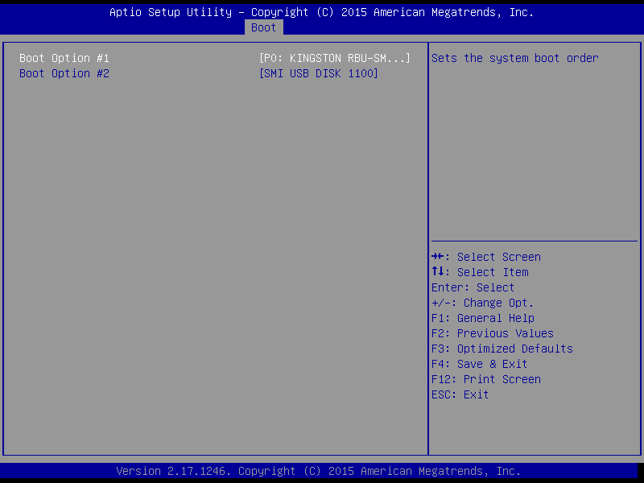

Exit Option
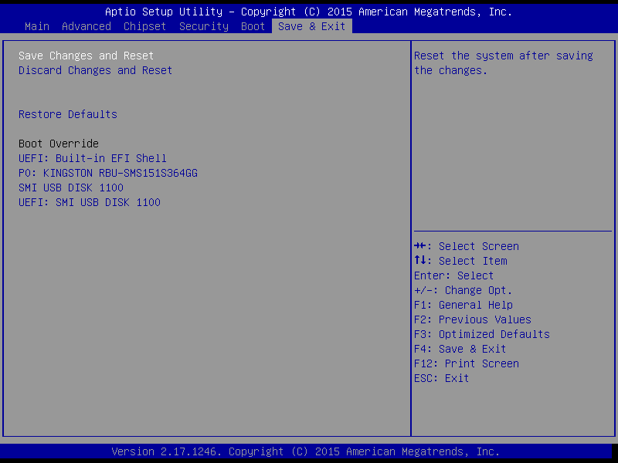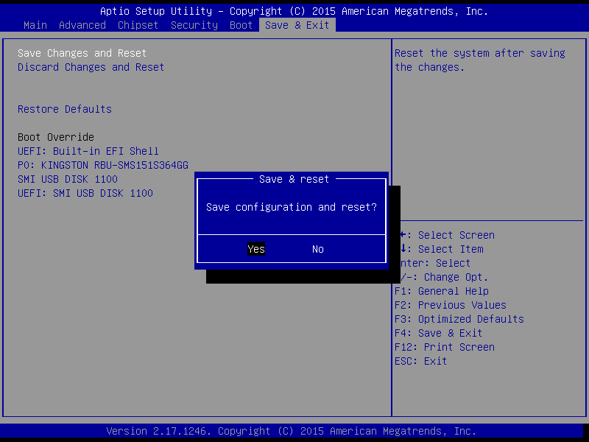

Save Changes and Exit
When you have completed system configuration, select this option to save your changes, exit BIOS setup and reboot the computer so the new system configuration parameters can take effect.
1. Select Exit Saving Changes from the Exit menu and press <Enter>. The following message appears: Save Configuration Changes and Exit Now? [Ok] [Cancel]
2. Select Ok or cancel.

Discard Changes and Exit
Select this option to quit Setup without making any permanent changes to the system configuration.
1. Select Exit Discarding Changes from the Exit menu and press <Enter>. The following message appears: Discard Changes and Exit Setup Now? [Ok] [Cancel]
1. Select Ok to discard changes and exit. Discard Changes
2. Select Discard Changes from the Exit menu and press <Enter>.

Load Optimal Defaults
The eBOX-3310 automatically configures all setup items to optimal settings when you select this option. Optimal Defaults are designed for maximum system performance, but may not work best for all computer applications. In particular, do not use the Optimal Defaults if your computer is experiencing system configuration problems. Select Load Optimal Defaults from the Exit menu and press <Enter>.

Load Fail-Safe Defaults
The eBOX-3310 automatically configures all setup options to fail-safe settings when you select this option. Fail-Safe Defaults are designed for maximum system stability, but not maximum performance. Select Fail-Safe Defaults if your computer is experiencing system configuration problems.
1. Select Load Fail-Safe Defaults from the Exit menu and press <Enter>. The following message appears: Load Fail-Safe Defaults? [OK] [Cancel]
2. Select OK to load Fail-Safe defaults.

Chapter 4

System Maintenance

System Maintenance Introduction
If the components of the eBOX-3310 fail they must be replaced, such asthe wireless LAN module or the motherboard. Please contact the system reseller orvendor to purchase the replacement parts. Back cover removal instructions and jumpersettings for the eBOX-3310 are described below.

Motherboard Replacement
In the case of motherboard failure, please contact an IEI sales representative, reseller orsystem vendor. The motherboard is accessible after opening the rear cover.

Cover Removal
Warning:
Turn off the power before removing the back cover. Risk of electrocution. Severe damage to the product and injury to the body may occur if internal parts are touched while the power is still on.

Warning:
Take anti-static precautions when working on the internal components. Some internal components are easily damaged or destroyed by electrostatic discharge. Take anti-static precautions to prevent electrostatic discharge.

To replace any of the following components,
- Memory module
- Wireless LAN module
- Inverter
The back cover of the eBOX-3310 must be removed. To remove the back cover, loosen the screws, slide the cover down and then lift to remove.

A

Safety Precautions

Warning:
The precautions outlined in this chapter should be strictly followed. Failure to follow these precautions may result in permanent damage to the eBOX-3310:

A.1 Safety Precautions
Please follow the safety precautions outlined in the sections that follow:

A.1.1 General Safety Precautions
Please ensure the following safety precautions are adhered to at all times.
- Follow the electrostatic precautions outlined below whenever theeBOX-3310 is opened.
- Make sure the power is turned off and the power cord is disconnected whenever the eBOX-3310 is being installed, moved or modified.
- Do not apply voltage levels that exceed the specified voltage range. Doing so may cause fire and/or an electrical shock.
- Electric shocks can occur if the eBOX-3310 chassis is opened when the eBOX-3310 is running.
- Do not drop or insert any objects into the ventilation openings of theeBOX-3310.
- If considerable amounts of dust, water, or fluids enter theeBOX-3310, turn off the power supply immediately, unplug the power cord, and contact the eBOX-3310 vendor.
- DO NOT do the following:
- DO NOT drop the eBOX-3310 against a hard surface.
- DO NOT strike or exert excessive force onto the LCD panel.
- DO NOT touch any of the LCD panels with a sharp object.
- DO NOT use the eBOX-3310 in a site where the ambient temperature exceeds the rated temperature

A.1.2 Anti-static Precautions
Warning:
Failure to take ESD precautions during the installation of the eBOX-3310 may result in permanent damage to the eBOX-3310 and sever injury to the user.

Electrostatic discharge (ESD) can cause serious damage to electronic components, including the eBOX-3310. Dry climates are especially susceptible to ESD. It is therefore critical that whenever the eBOX-3310 is opened and any of the electrical components are handled, the following anti-static precautions are strictly adhered to.

- Wear an anti-static wristband: Wearing a simple anti-static wristband can help to prevent ESD from damaging any electrical component.
- Self-grounding: Before handling any electrical component, touch any grounded conducting material. During the time the electrical component is handled, frequently touch any conducting materials that are connected to the ground.
- Use an anti-static pad: When configuring or working with an electrical component, place it on an antic-static pad. This reduces the possibility of ESD damage.
- Only handle the edges of the electrical component: When handling the electrical component, hold the electrical component by its edges.

A.1.3 Product Disposal
CAUTION:
Risk of explosion if battery is replaced by and incorrect type, only certified engineers should replace the on-board battery.
Dispose of used batteries according to instructions and local regulations.

Outside the European Union - If you wish to dispose of used electrical and electronic products outside the European Union, please contact your local authority so as to comply with the correct disposal method. Within the European Union:

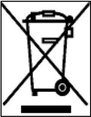
EU-wide legislation, as implemented in each Member State, requires that waste electrical and electronic products carrying the mark (left) must be disposed of separately from normal household waste. This includes monitors and electrical accessories, such as signal cables or power cords. When you need to dispose of your display products, please follow the guidance of your local authority, or ask the shop where you purchased the product. The mark on electrical and electronic products only applies to the current European Union Member States.
Please follow the national guidelines for electrical and electronic product disposal.

A.2 Maintenance and Cleaning Precautions
When maintaining or cleaning the eBOX-3310, please follow the guidelines below.

A.2.1 Maintenance and Cleaning
Prior to cleaning any part or component of the eBOX-3310, please read the details below.

- Except for the LCD panel, never spray or squirt liquids directly onto any other components. To clean the LCD panel, gently wipe it with a piece of soft dry cloth or a slightly moistened cloth.
- The interior does not require cleaning. Keep fluids away from the interior.
- Be careful not to damage the small, removable components inside.
- Turn off before cleaning.
- Never drop any objects or liquids through the openings.
- Be cautious of any possible allergic reactions to solvents or chemicals used when cleaning.
- Avoid eating, drinking and smoking nearby.

A.2.2 Cleaning Tools
Some components may only be cleaned using a product specifically designed for the purpose. In such case, the product will be explicitly mentioned in the cleaning tips. Below is a list of items to use for cleaning.

- Cloth – Although paper towels or tissues can be used, a soft, clean piece of cloth is recommended.
- Water or rubbing alcohol – A cloth moistened with water or rubbing alcohol should be used.
- Using solvents – The use of solvents is not recommended as they may damage the plastic parts.
- Vacuum cleaner – Using a vacuum specifically designed for computers is one of the best methods of cleaning. Dust and dirt can restrict the airflow and cause circuitry to corrode
- Cotton swabs - Cotton swaps moistened with rubbing alcohol or water are excellent tools for wiping hard to reach areas.
- Foam swabs - Whenever possible, it is best to use lint free swabs such as f oam swabs for cleaning.

B

ALC662 Digital
Microphone Configuration

B.1 ALC662 Digital Microphone Configuration
To enable the ALC662 digital microphone function, follow the steps below.
Step 1: Make sure the Realtek ALC662 high definition audio driver has been installed on the system.
Step 2: To launch the Realtek ALC662 HD Audio Manager, double click either:
- The Realtek HDAudio Manager icon in the Notification Area of the system task bar (Figure B-1), or
- The Realtek HD Audio Manager icon in the Control Panel.

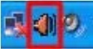
Figure B-1: Realtek HD Audio Manager Icon [Task Bar]

Step 3: The Realtek HD Audio Manager appears (Figure B-2).

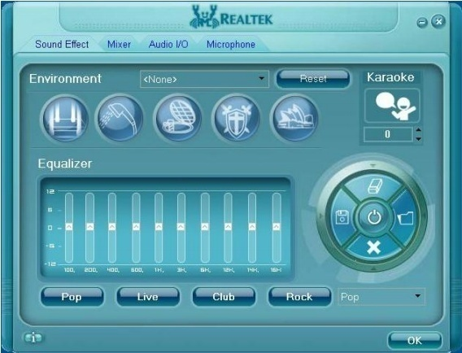
Figure B-2: Realtek HD Audio Manager

Step 4: Click the Mixer tab.
Step 5: Select Mic Volume in the Record section (Figure B-3).The digital microphone function is now enabled.
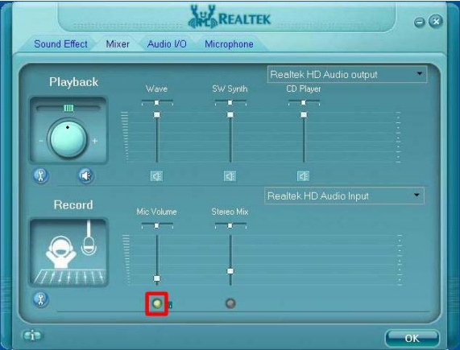
Figure B-3: Enabling the Digital Microphone Function

Step 6: Move the slide bar to adjust the microphone volume (Figure B-4).

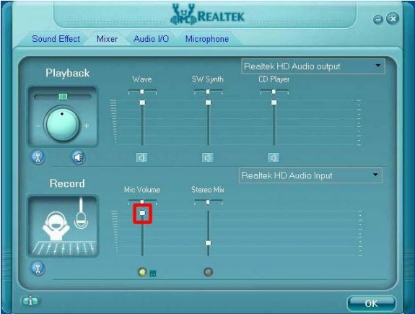
Figure B-4: Adjusting the Microphone Volume

Step 7: Click the Advanced icon (Figure B-5) to display the advanced setting screen.

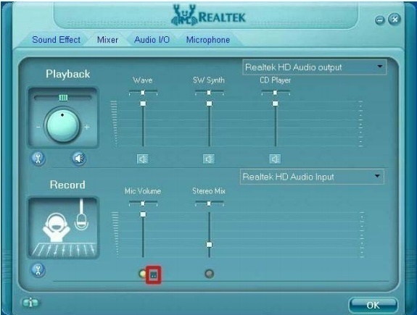
Figure B-5: Mixer ToolBox Screen

Step 8: In the Advanced setting screen (Figure B-6), the user may turn on the Microphone Boost function.

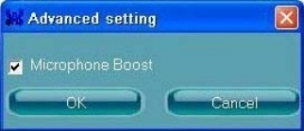
Figure B-6: Advanced Setting Screen

C

Watchdog Timer

NOTE:
The following discussion applies to DOS environment. NODKA support is contacted or the NODKA website visited for specific drivers for more sophisticated operating systems, e.g., Windows and Linux.

The Watchdog Timer is provided to ensure that standalone systems can always recover from catastrophic conditions that cause the CPU to crash. This condition may have occurred by external EMIs or a software bug. When the CPU stops working correctly, Watchdog Timer either performs a hardware reset (cold boot) or a Non-Mask able Interrupt(NMI) to bring the system back to a known state. A BIOS function call (INT 15H) is used to control the Watchdog Timer.

INT 15H:
AH-6FH Sub-function
AL – 2: | Sets the Watchdog Timer’s period.
BL: | Time-out value (Its unit-second is dependent on the item “Watchdog Timer unit select” in CMOS setup).
Table C-1: AH-6FH Sub-function

Call sub-function 2 to set the time-out period of Watchdog Timer first. If the time-out value is not zero, the Watchdog Timer starts counting down. When the timer value reaches zero, the system resets. To ensure that this reset condition does not occur, calling sub-function2 must periodically refresh the Watchdog Timer. However, the watchdog timer is disabled if the time-out value is set to zero.
A tolerance of at least 10% must be maintained to avoid unknown routines within the operating system (DOS), such as disk I/O that can be very time-consuming.

NOTE:
When exiting a program it is necessary to disable the Watchdog Timer, otherwise the system resets.

Example program:

INITIAL TIMER PERIOD COUNTER
;
W_LOOP:
MOV AX, 6F02H ; //setting the time-out value
MOV BL, 30 ; //time-out value is 48 seconds
INT 15H
;

ADD THE APPLICATION PROGRAM HERE
;
CMP EXIT_AP, 1; //is the application over?
JNE W_LOOP; //No, restart the application
MOV AX, 6F02H; //disable Watchdog Timer
MOV BL, 0;
INT 15H
;
;
EXIT
;

D

Hazardous Materials
Disclosure

D.1 Hazardous Materials Disclosure Table for IPB ProductsCertified as RoHS Compliant Under 2002/95/EC withoutMercury
The details provided in this appendix are to ensure that the product is compliant with the Peoples Republic of China (China) RoHS standards. The table below acknowledges the presences of small quantities of certain materials in the product, and is applicable to China RoHS only.
A label will be placed on each product to indicate the estimated “Environmentally Friendly Use Period” (EFUP). This is an estimate of the number of years that these substances would “not leak out or undergo abrupt change.” This product may contain replace able sub-assemblies/components which have a shorter EFUP such as batteries and lamps. These components will be separately marked.
Please refer to the table below.

Part Name | Toxic or Hazardous Substances and Elements
 | Lead(Pb) | Mercury(Hg) | Cadmium(Cd) | HexavalentChromium(CR(VI)) | PolybrominatedBiphenyls(PBB) | PolybrominatedDiphenyl Ethers(PBDE)
Housing | X | O | O | O | O | X
Housing | X | O | O | O | O | X
Printed CircuitBoard | X | O | O | O | O | X
Metal Fasteners | X | O | O | O | O | O
Cable Assembly | X | O | O | O | O | X
Fan Assembly | X | O | O | O | O | X
Fan Assembly | X | O | O | O | O | X
Battery | O | O | O | O | O | O
O: This toxic or hazardous substance is contained in all of the homogeneous materials for the part is below the limit requirement in SJ/T11363-2006
X: This toxic or hazardous substance is contained in at least one of the homogeneous materials for this part is above the limit requirement in SJ/T11363-2006
Table D-1

，

